Hardware
# Source: AI Source: Provided by: [Data Path: Persons Table -> ID Column: 1, Name_En Column: Motasem Essam] -> From: [ChatGPT] on [4/22/2026]
Hardware refers to all the physical parts of a computer system that you can see and touch.

🧠 Simple idea
# Source: AI Source: Provided by: [Data Path: Persons Table -> ID Column: 1, Name_En Column: Motasem Essam] -> From: [ChatGPT] on [4/22/2026]
Hardware is the body of the computer—the actual devices that perform work.

🖥️Hardware Types
# Source: AI Source: Provided by: [Data Path: Persons Table -> ID Column: 1, Name_En Column: Motasem Essam] -> From: [ChatGPT] on [4/22/2026]
Hardware can be grouped in two main ways:
- By location (internal vs external)
- By function (what role the device plays in computer operations)

🔹 1. Internal Hardware
# Source: AI Source: Provided by: [Data Path: Persons Table -> ID Column: 1, Name_En Column: Motasem Essam] -> From: [ChatGPT] on [4/22/2026]
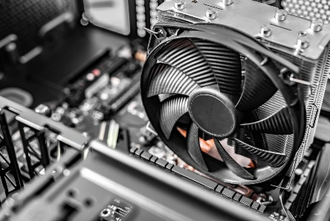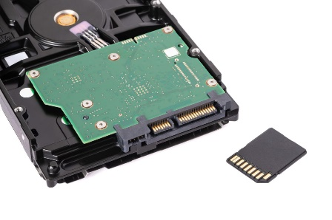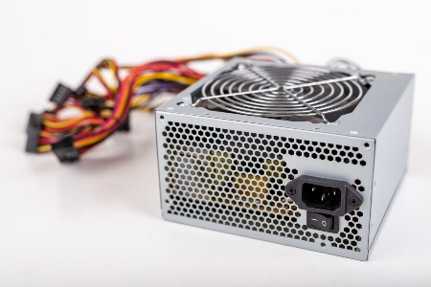
Internal hardware is located inside the computer case.
Examples:
- CPU (Central Processing Unit)
- RAM (Memory)
- Motherboard
- Hard disk / SSD
- Power supply
- Graphics card
👉 These parts are essential for the computer to work.

🔹 2. External Hardware
# Source: AI Source: Provided by: [Data Path: Persons Table -> ID Column: 1, Name_En Column: Motasem Essam] -> From: [ChatGPT] on [4/22/2026]
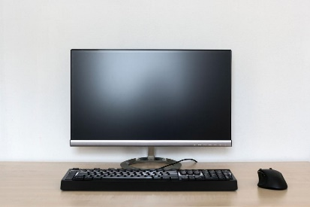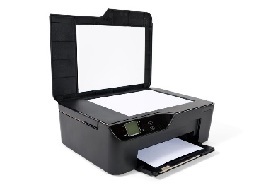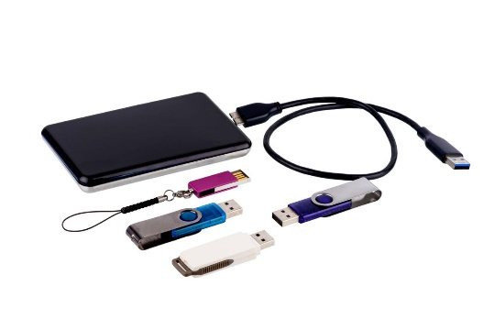
External hardware (peripherals) are devices outside the computer that connect to it.
Examples:
- Keyboard and mouse
- Monitor
- Printer and scanner
- Speakers, webcam
- USB drives
👉 These help users interact with the computer.

⚙️ 3. Hardware Based on Computer Operations
# Source: AI Source: Provided by: [Data Path: Persons Table -> ID Column: 1, Name_En Column: Motasem Essam] -> From: [ChatGPT] on [4/22/2026]
Hardware devices are also classified based on the five main operations of a computer system:

⌨️ Input Devices
# Source: AI Source: Provided by: [Data Path: Persons Table -> ID Column: 1, Name_En Column: Motasem Essam] -> From: [ChatGPT] on [4/22/2026]
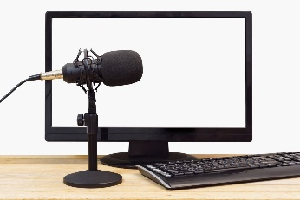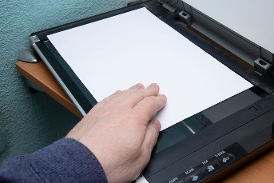
- Used to enter data into the computer
- Examples: keyboard, mouse, scanner, microphone, touch pads, touch screens, fingerprint readers

🧠 Processing Devices
# Source: AI Source: Provided by: [Data Path: Persons Table -> ID Column: 1, Name_En Column: Motasem Essam] -> From: [ChatGPT] on [4/22/2026]
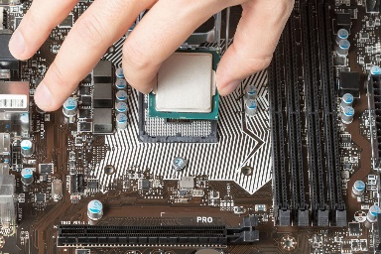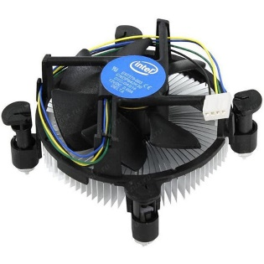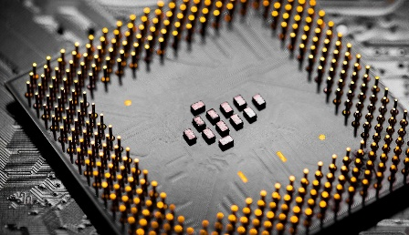
- Used to process data
- Example: CPU (the brain of the computer), memory

🖨️ Output Devices
# Source: AI Source: Provided by: [Data Path: Persons Table -> ID Column: 1, Name_En Column: Motasem Essam] -> From: [ChatGPT] on [4/22/2026]
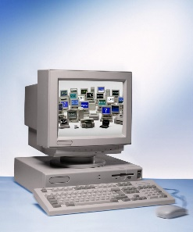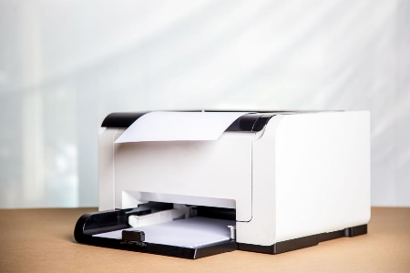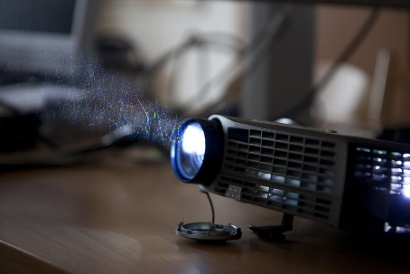
- Used to display results
- Examples: monitor, printer, speakers, projector

💾 Storage Devices
# Source: AI Source: Provided by: [Data Path: Persons Table -> ID Column: 1, Name_En Column: Motasem Essam] -> From: [ChatGPT] on [4/22/2026]
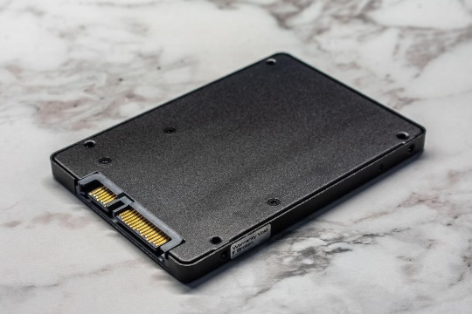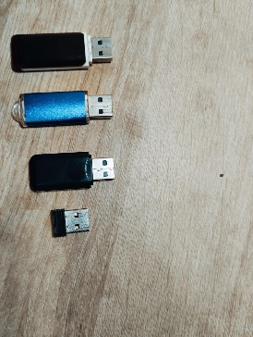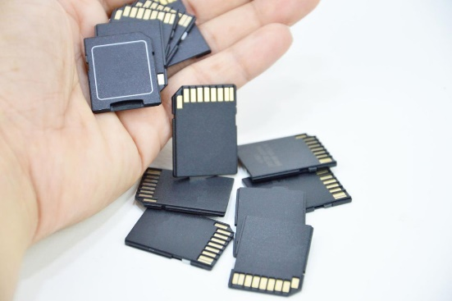
- Used to store data and information
- Examples: hard disk, SSD, USB, memory card, CD/DVD discs, drives

🌐 Communication Devices
# Source: AI Source: Provided by: [Data Path: Persons Table -> ID Column: 1, Name_En Column: Motasem Essam] -> From: [ChatGPT] on [4/22/2026]
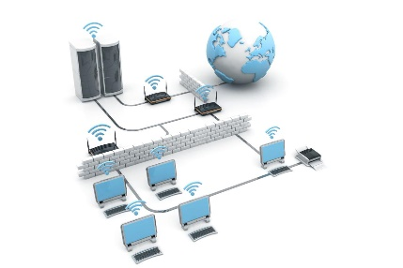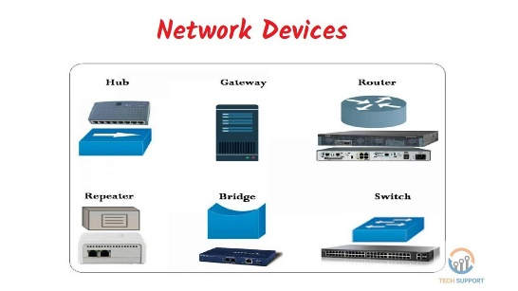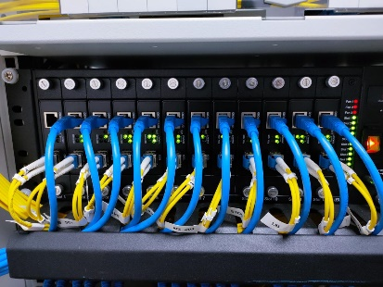
- Used to connect computers and share data
- Examples: modem, router, network card (network adapter)

🧾 One-line summary
# Source: AI Source: Provided by: [Data Path: Persons Table -> ID Column: 1, Name_En Column: Motasem Essam] -> From: [ChatGPT] on [4/22/2026]
Hardware types can be classified by location (internal/external) and by function (input, processing, output, storage, communication).

🔧 Examples of hardware
# Source: AI Source: Provided by: [Data Path: Persons Table -> ID Column: 1, Name_En Column: Motasem Essam] -> From: [ChatGPT] on [4/22/2026]
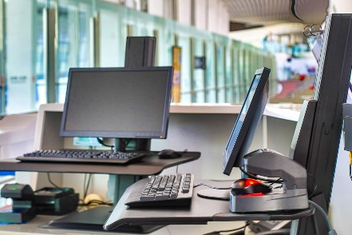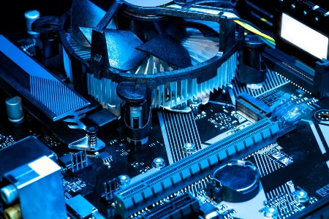
- Input devices: keyboard, mouse, scanner
- Output devices: monitor, printer, speakers
- Processing device: CPU (processor)
- Storage devices: hard disk, SSD, USB

Hardware Components
# Source: Academic source: Provided by: [Data Path: Persons Table -> ID Column: 1, Name_En Column: Motasem Essam] -> From: [Data Path: Sources Table -> ID Column: 158, Content Title Column: Academic Source - Modern academy - 2017-2018 - Intro to Computer Science - Computer systems] -> at: [Document, page: 5, top, “Image - Tool: [Lightshot Program]”] on [4/22/2026]
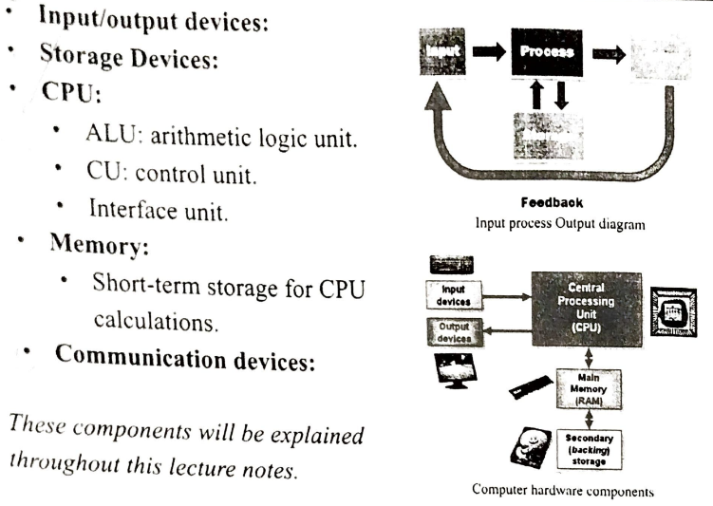

Typical Personal Computer System
# Source: Academic source: Provided by: [Data Path: Persons Table -> ID Column: 1, Name_En Column: Motasem Essam] -> From: [Data Path: Sources Table -> ID Column: 158, Content Title Column: Academic Source - Modern academy - 2017-2018 - Intro to Computer Science - Computer systems] -> at: [Document, page: 5, bottom, “Image - Tool: [Lightshot Program]”] on [4/22/2026]
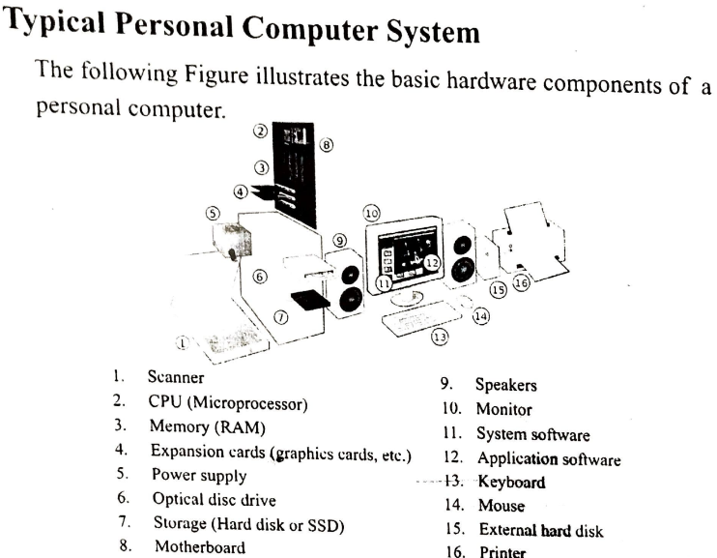

CPU: Central Processing Unit
# Source: Academic source: Provided by: [Data Path: Persons Table -> ID Column: 1, Name_En Column: Motasem Essam] -> From: [Data Path: Sources Table -> ID Column: 158, Content Title Column: Academic Source - Modern academy - 2017-2018 - Intro to Computer Science - Computer systems] -> at: [Document, page: 6, (Top, middle, botoom), “Image - Tool: [Lightshot Program]”] on [4/22/2026]
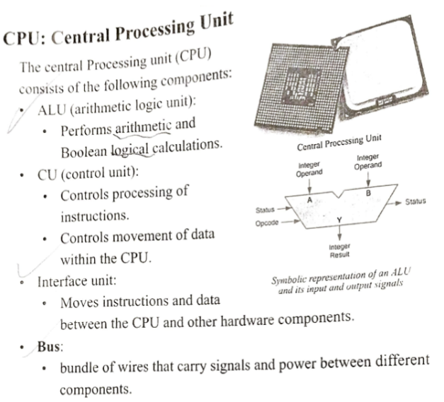
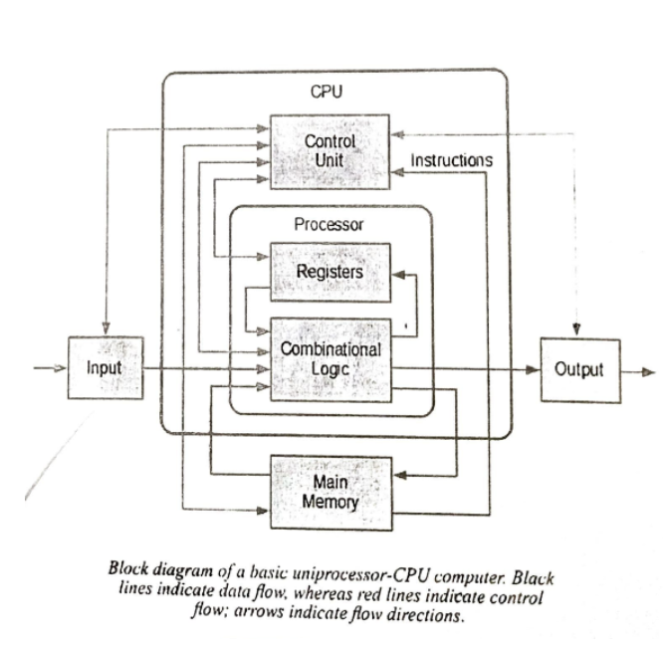

# Source: Academic source: Provided by: [Data Path: Persons Table -> ID Column: 1, Name_En Column: Motasem Essam] -> From: [Data Path: Sources Table -> ID Column: 159, Content Title Column: Academic Source - Modern academy - 2017-2018 - Intro to Computer Science - The System Unit processing and memory] -> at: [Document, page: 18, (middle, Bottom), “Image - Tool: [Lightshot Program]”] on [4/22/2026]
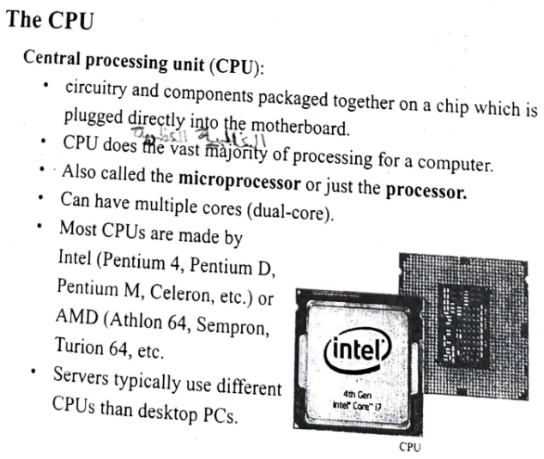

Processing Speed
# Source: Academic source: Provided by: [Data Path: Persons Table -> ID Column: 1, Name_En Column: Motasem Essam] -> From: [Data Path: Sources Table -> ID Column: 159, Content Title Column: Academic Source - Modern academy - 2017-2018 - Intro to Computer Science - The System Unit processing and memory] -> at: [Document, page: 19, )top, middle,bottom), “Image - Tool: [Lightshot Program]”] on [4/22/2026]
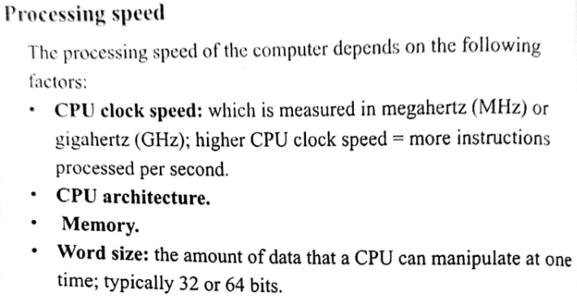
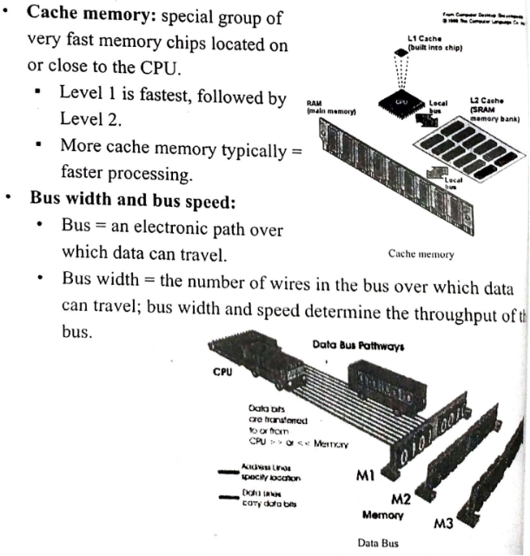

How the CPU Works
# Source: Academic source: Provided by: [Data Path: Persons Table -> ID Column: 1, Name_En Column: Motasem Essam] -> From: [Data Path: Sources Table -> ID Column: 159, Content Title Column: Academic Source - Modern academy - 2017-2018 - Intro to Computer Science - The System Unit processing and memory] -> at: [Document, page: 24, all, “Image - Tool: [Lightshot Program]”] on [4/22/2026]
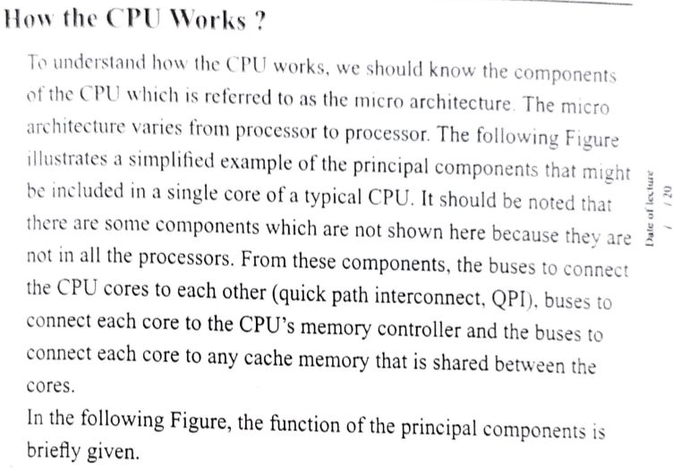
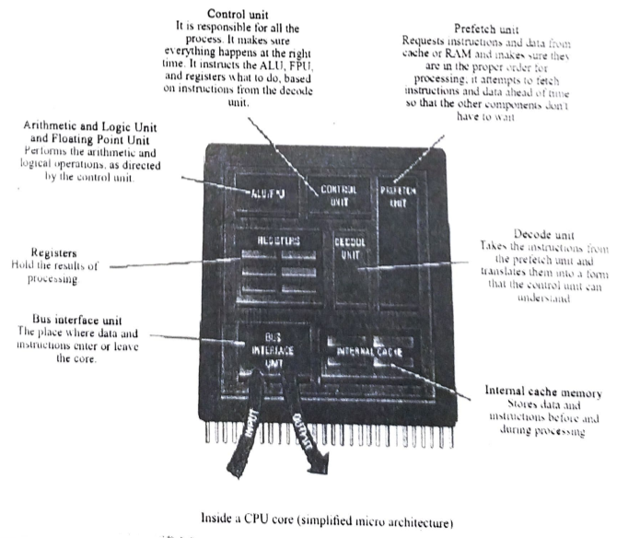

The System Clock and the Machine Cycle
# Source: Academic source: Provided by: [Data Path: Persons Table -> ID Column: 1, Name_En Column: Motasem Essam] -> From: [Data Path: Sources Table -> ID Column: 159, Content Title Column: Academic Source - Modern academy - 2017-2018 - Intro to Computer Science - The System Unit processing and memory] -> at: [Document, page: 25, all, “Image - Tool: [Lightshot Program]”] on [4/22/2026]
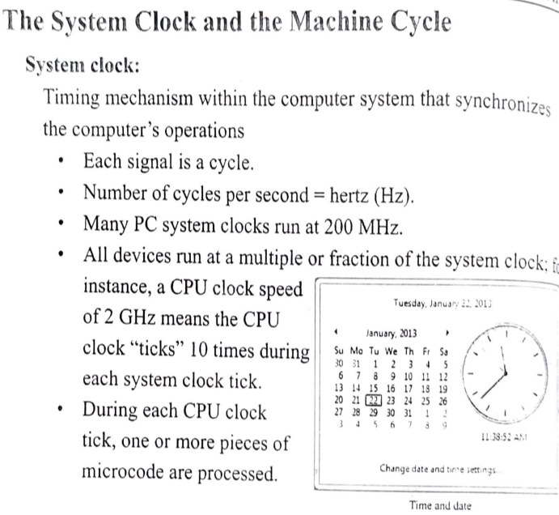
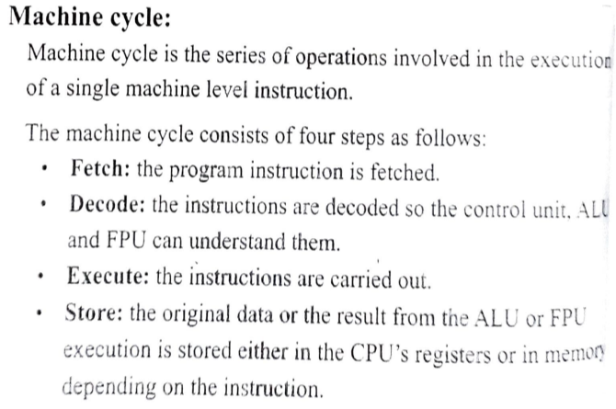

# Source: Academic source: Provided by: [Data Path: Persons Table -> ID Column: 1, Name_En Column: Motasem Essam] -> From: [Data Path: Sources Table -> ID Column: 159, Content Title Column: Academic Source - Modern academy - 2017-2018 - Intro to Computer Science - The System Unit processing and memory] -> at: [Document, page: 26, all, “Image - Tool: [Lightshot Program]”] on [4/22/2026]
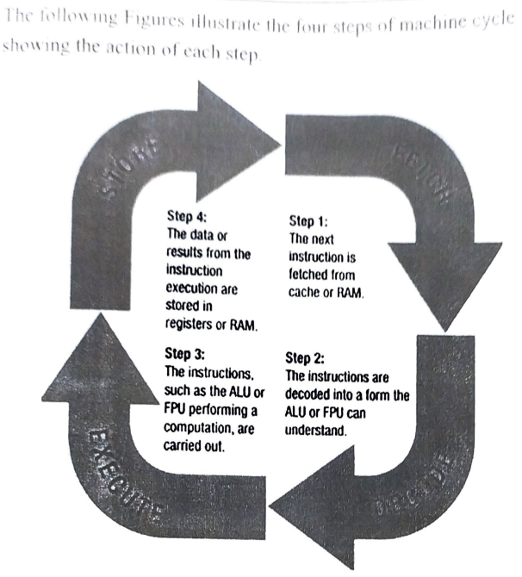
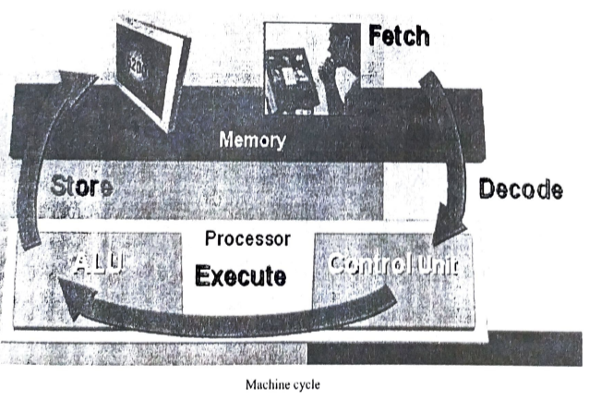

# Source: Academic source: Provided by: [Data Path: Persons Table -> ID Column: 1, Name_En Column: Motasem Essam] -> From: [Data Path: Sources Table -> ID Column: 159, Content Title Column: Academic Source - Modern academy - 2017-2018 - Intro to Computer Science - The System Unit processing and memory] -> at:[Document, page: 27, all, “Image - Tool: [Lightshot Program]”] on [4/22/2026]
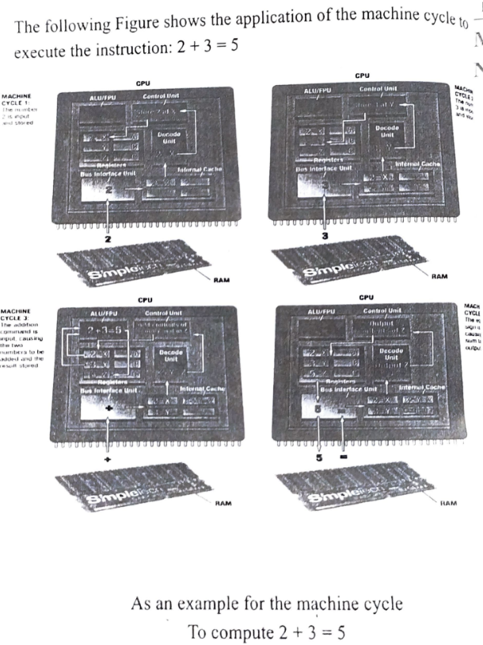

Input and Output Devices

Input Device

Keyboard
# Source: Academic source: Provided by: [Data Path: Persons Table -> ID Column: 1, Name_En Column: Motasem Essam] -> From: [Data Path: Sources Table -> ID Column: 161, Content Title Column: Academic Source - Modern academy - 2017-2018 - Intro to Computer Science - Input and output devices] -> at: [Document, page: 3, all, “Image - Tool: [Lightshot Program]”] on [4/22/2026]
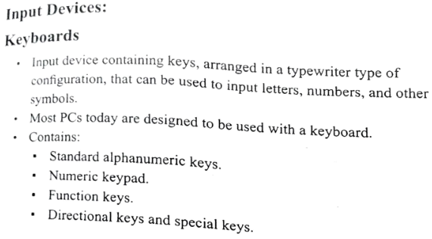
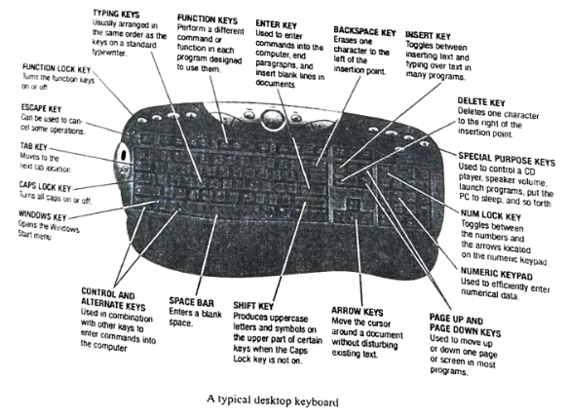

# Source: Academic source: Provided by: [Data Path: Persons Table -> ID Column: 1, Name_En Column: Motasem Essam] -> From: [Data Path: Sources Table -> ID Column: 161, Content Title Column: Academic Source - Modern academy - 2017-2018 - Intro to Computer Science - Input and output devices] -> at: [Document, page: 4, (top, middle), “Image - Tool: [Lightshot Program]”] on [4/22/2026]
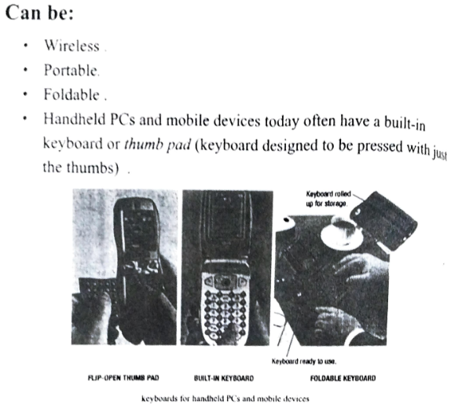

Pointing Device
# Source: Academic source: Provided by: [Data Path: Persons Table -> ID Column: 1, Name_En Column: Motasem Essam] -> From: [Data Path: Sources Table -> ID Column: 161, Content Title Column: Academic Source - Modern academy - 2017-2018 - Intro to Computer Science - Input and output devices] -> at: [Document, page: 4, bottom, “Image - Tool: [Lightshot Program]”] on [4/22/2026]
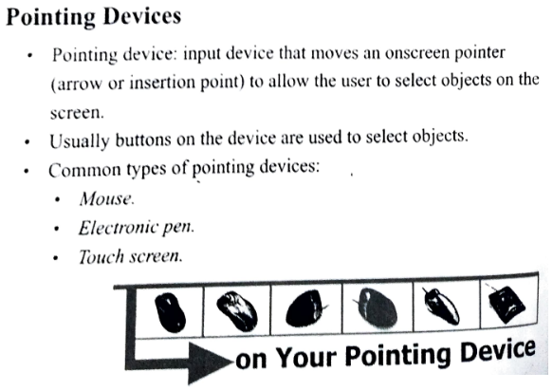

Mouse
# Source: Academic source: Provided by: [Data Path: Persons Table -> ID Column: 1, Name_En Column: Motasem Essam] -> From: [Data Path: Sources Table -> ID Column: 161, Content Title Column: Academic Source - Modern academy - 2017-2018 - Intro to Computer Science - Input and output devices] -> at: [Document, page: 5, all, “Image - Tool: [Lightshot Program]”] on [4/22/2026]
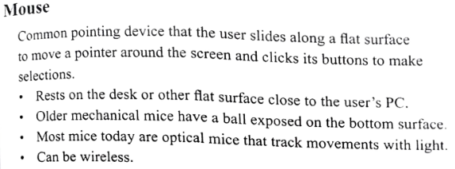
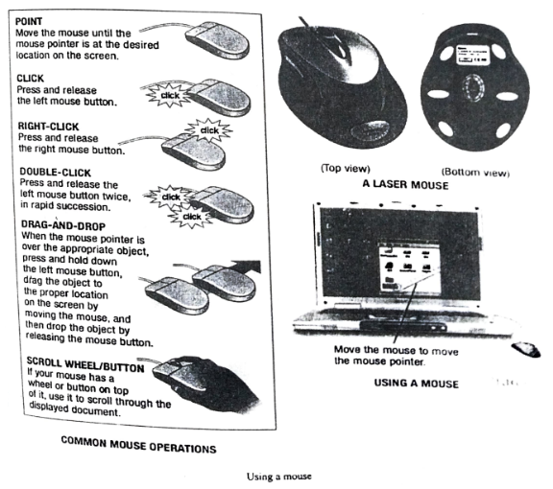

Electronic Pen
# Source: Academic source: Provided by: [Data Path: Persons Table -> ID Column: 1, Name_En Column: Motasem Essam] -> From: [Data Path: Sources Table -> ID Column: 161, Content Title Column: Academic Source - Modern academy - 2017-2018 - Intro to Computer Science - Input and output devices] -> at: [Document, page: 6, all, “Image - Tool: [Lightshot Program]”] on [4/22/2026]
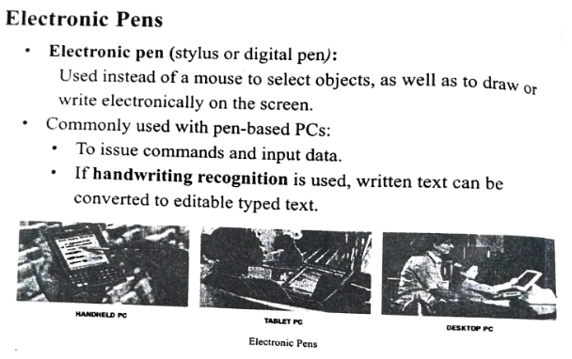
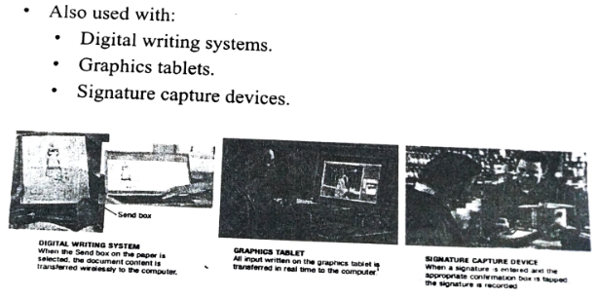

Touch Screens
# Source: Academic source: Provided by: [Data Path: Persons Table -> ID Column: 1, Name_En Column: Motasem Essam] -> From: [Data Path: Sources Table -> ID Column: 161, Content Title Column: Academic Source - Modern academy - 2017-2018 - Intro to Computer Science - Input and output devices] -> at: [Document, page: 7, all, “Image - Tool: [Lightshot Program]”] on [4/22/2026]
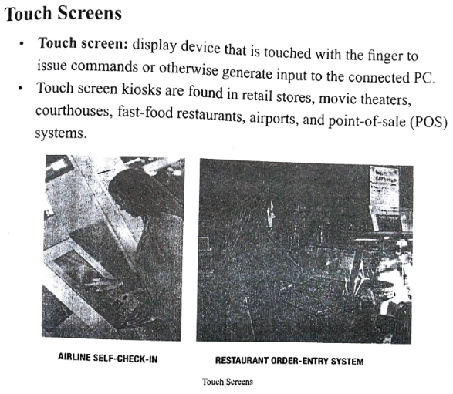

Other Pointing Devices
# Source: Academic source: Provided by: [Data Path: Persons Table -> ID Column: 1, Name_En Column: Motasem Essam] -> From: [Data Path: Sources Table -> ID Column: 161, Content Title Column: Academic Source - Modern academy - 2017-2018 - Intro to Computer Science - Input and output devices] -> at: [Document, page: 8, all, “Image - Tool: [Lightshot Program]”] on [4/22/2026]
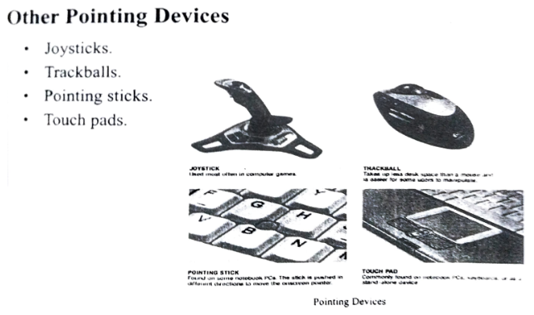

Screen Reader and Digital Camera
# Source: Academic source: Provided by: [Data Path: Persons Table -> ID Column: 1, Name_En Column: Motasem Essam] -> From: [Data Path: Sources Table -> ID Column: 161, Content Title Column: Academic Source - Modern academy - 2017-2018 - Intro to Computer Science - Input and output devices] -> at: [Document, page: 9, all, “Image - Tool: [Lightshot Program]”] on [4/22/2026]
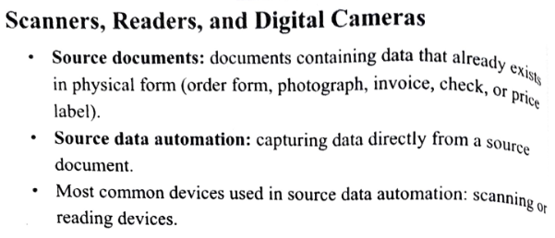
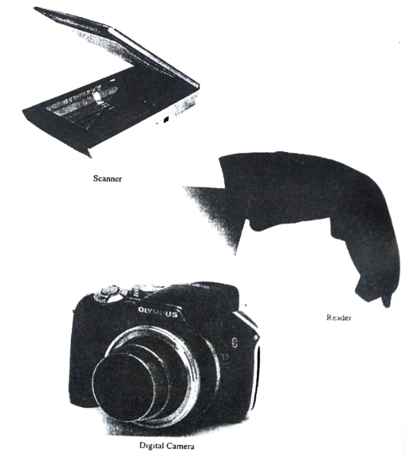

Scanner
# Source: Academic source: Provided by: [Data Path: Persons Table -> ID Column: 1, Name_En Column: Motasem Essam] -> From: [Data Path: Sources Table -> ID Column: 161, Content Title Column: Academic Source - Modern academy - 2017-2018 - Intro to Computer Science - Input and output devices] -> at: [Document, page: 10, all, “Image - Tool: [Lightshot Program]”] on [4/22/2026]
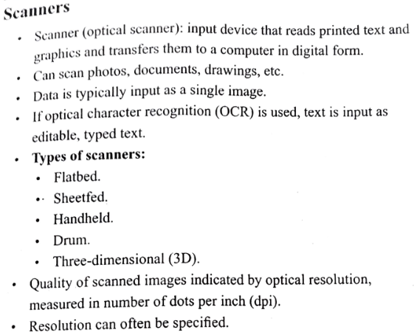
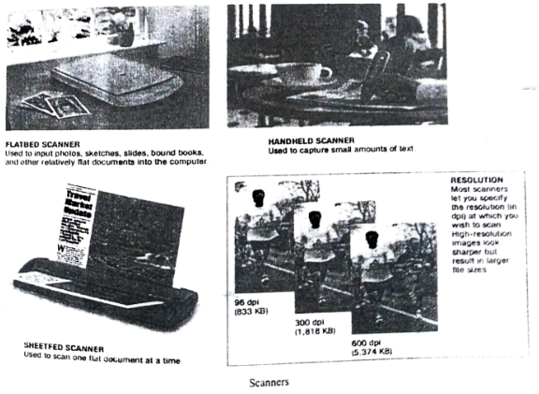

Reader
# Source: Academic source: Provided by: [Data Path: Persons Table -> ID Column: 1, Name_En Column: Motasem Essam] -> From: [Data Path: Sources Table -> ID Column: 161, Content Title Column: Academic Source - Modern academy - 2017-2018 - Intro to Computer Science - Input and output devices] -> at: [Document, page: 11, all, “Image - Tool: [Lightshot Program]”] on [4/22/2026]
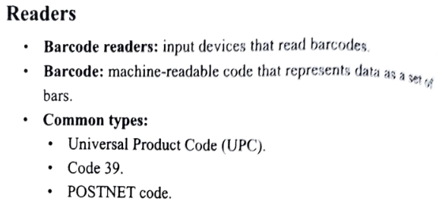
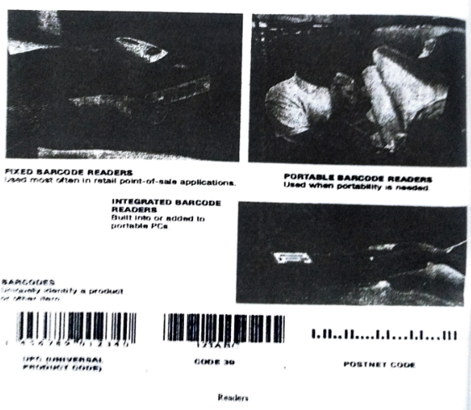

RFID
# Source: Academic source: Provided by: [Data Path: Persons Table -> ID Column: 1, Name_En Column: Motasem Essam] -> From: [Data Path: Sources Table -> ID Column: 161, Content Title Column: Academic Source - Modern academy - 2017-2018 - Intro to Computer Science - Input and output devices] -> at: [Document, page: 12, all, “Image - Tool: [Lightshot Program]”] on [4/22/2026]
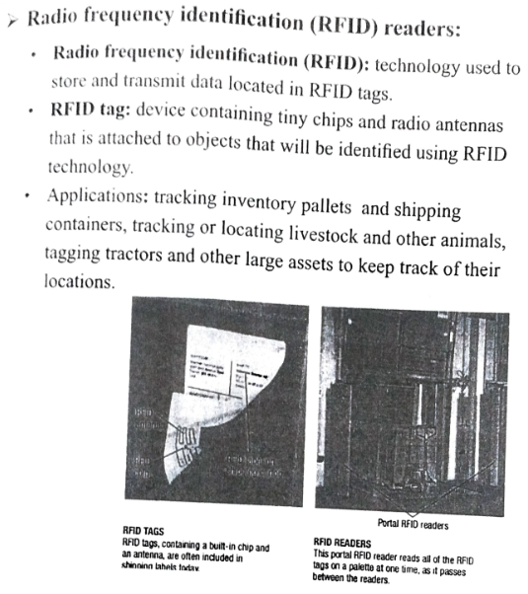
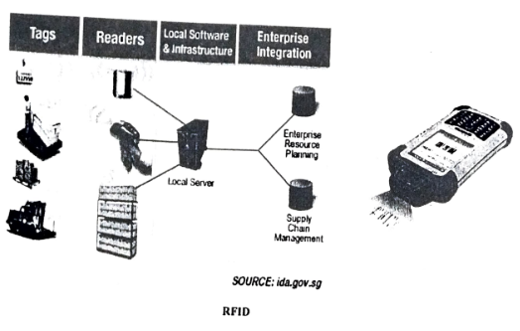

OMR
# Source: Academic source: Provided by: [Data Path: Persons Table -> ID Column: 1, Name_En Column: Motasem Essam] -> From: [Data Path: Sources Table -> ID Column: 161, Content Title Column: Academic Source - Modern academy - 2017-2018 - Intro to Computer Science - Input and output devices] -> at: [Document, page: 13, all, “Image - Tool: [Lightshot Program]”] on [4/22/2026]
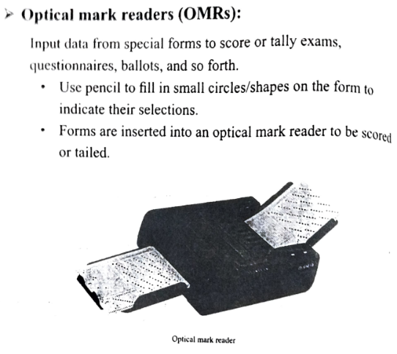
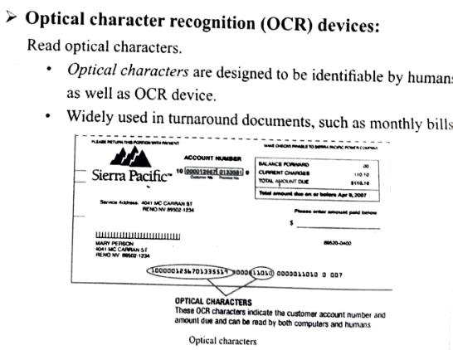

MICR
# Source: Academic source: Provided by: [Data Path: Persons Table -> ID Column: 1, Name_En Column: Motasem Essam] -> From: [Data Path: Sources Table -> ID Column: 161, Content Title Column: Academic Source - Modern academy - 2017-2018 - Intro to Computer Science - Input and output devices] -> at: [Document, page: 14, top, “Image - Tool: [Lightshot Program]”] on [4/22/2026]
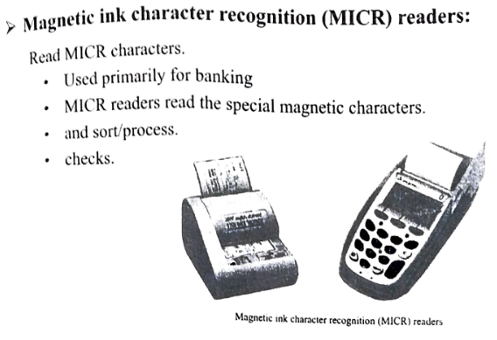

Biometric Reader
# Source: Academic source: Provided by: [Data Path: Persons Table -> ID Column: 1, Name_En Column: Motasem Essam] -> From: [Data Path: Sources Table -> ID Column: 161, Content Title Column: Academic Source - Modern academy - 2017-2018 - Intro to Computer Science - Input and output devices] -> at: [Document, page: 14, (middle, bottom), “Image - Tool: [Lightshot Program]”] on [4/22/2026]
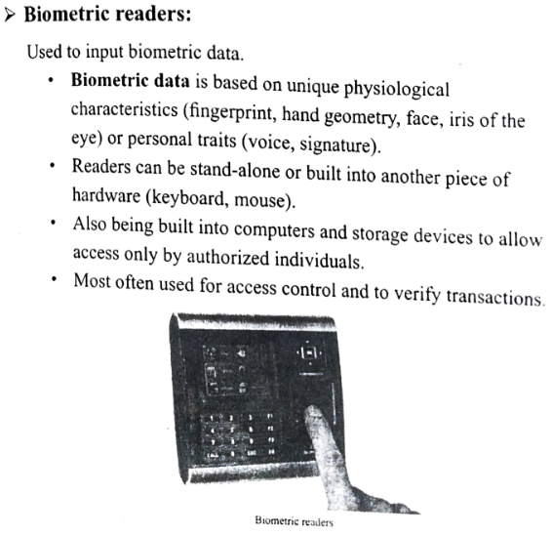

Digital Cameras
# Source: Academic source: Provided by: [Data Path: Persons Table -> ID Column: 1, Name_En Column: Motasem Essam] -> From: [Data Path: Sources Table -> ID Column: 161, Content Title Column: Academic Source - Modern academy - 2017-2018 - Intro to Computer Science - Input and output devices] -> at: [Document, page: 15, all, “Image - Tool: [Lightshot Program]”] on [4/22/2026]
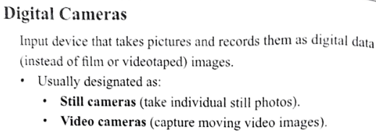
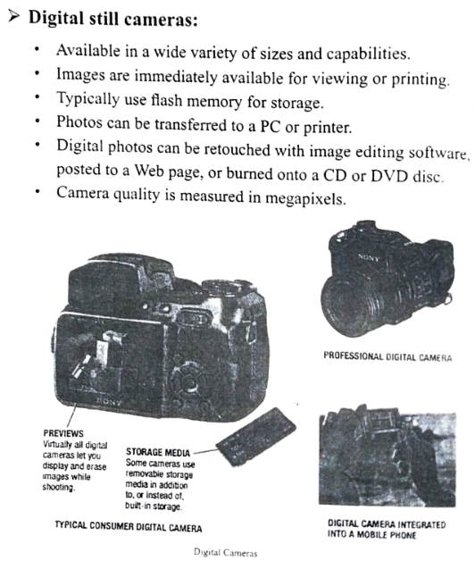

Digital Video Cameras
# Source: Academic source: Provided by: [Data Path: Persons Table -> ID Column: 1, Name_En Column: Motasem Essam] -> From: [Data Path: Sources Table -> ID Column: 161, Content Title Column: Academic Source - Modern academy - 2017-2018 - Intro to Computer Science - Input and output devices] -> at: [Document, page: 16, all, “Image - Tool: [Lightshot Program]”] on [4/22/2026]
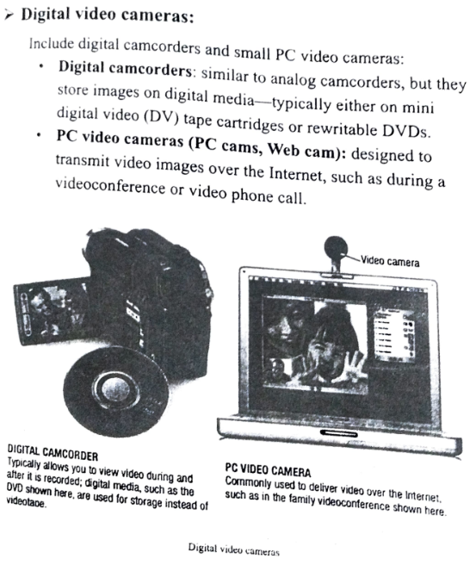

Audio Input
# Source: Academic source: Provided by: [Data Path: Persons Table -> ID Column: 1, Name_En Column: Motasem Essam] -> From: [Data Path: Sources Table -> ID Column: 161, Content Title Column: Academic Source - Modern academy - 2017-2018 - Intro to Computer Science - Input and output devices] -> at: [Document, page: 17, all, “Image - Tool: [Lightshot Program]”] on [4/22/2026]
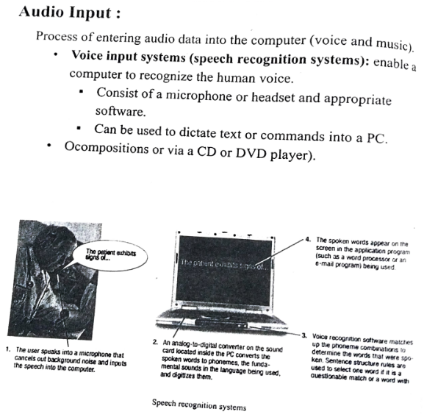

Output Device

Display Device
# Source: Academic source: Provided by: [Data Path: Persons Table -> ID Column: 1, Name_En Column: Motasem Essam] -> From: [Data Path: Sources Table -> ID Column: 161, Content Title Column: Academic Source - Modern academy - 2017-2018 - Intro to Computer Science - Input and output devices] -> at: [Document, page: 18, all, “Image - Tool: [Lightshot Program]”] on [4/22/2026]
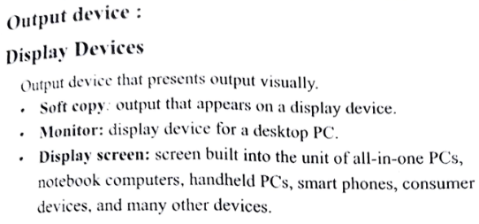
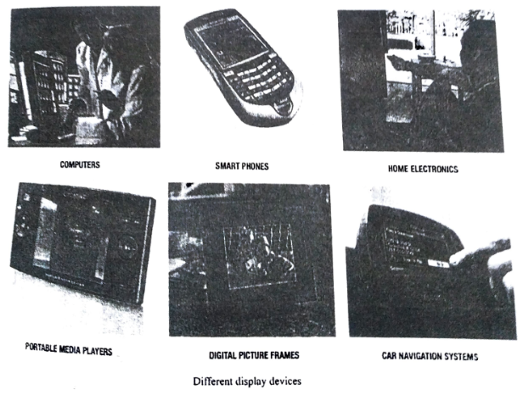

Display Device Characteristics
# Source: Academic source: Provided by: [Data Path: Persons Table -> ID Column: 1, Name_En Column: Motasem Essam] -> From: [Data Path: Sources Table -> ID Column: 161, Content Title Column: Academic Source - Modern academy - 2017-2018 - Intro to Computer Science - Input and output devices] -> at: [Document, page: 19, top, “Image - Tool: [Lightshot Program]”] on [4/22/2026]
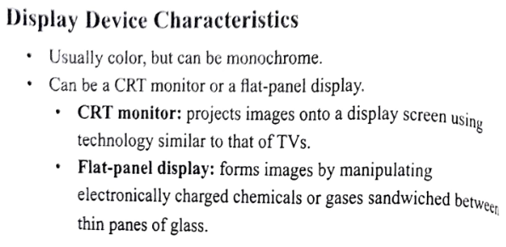

CRT vs Flat-Panel Monitors
# Source: Academic source: Provided by: [Data Path: Persons Table -> ID Column: 1, Name_En Column: Motasem Essam] -> From: [Data Path: Sources Table -> ID Column: 161, Content Title Column: Academic Source - Modern academy - 2017-2018 - Intro to Computer Science - Input and output devices] -> at: [Document, page: 19, (middle, bottom), “Image - Tool: [Lightshot Program]”] on [4/22/2026]
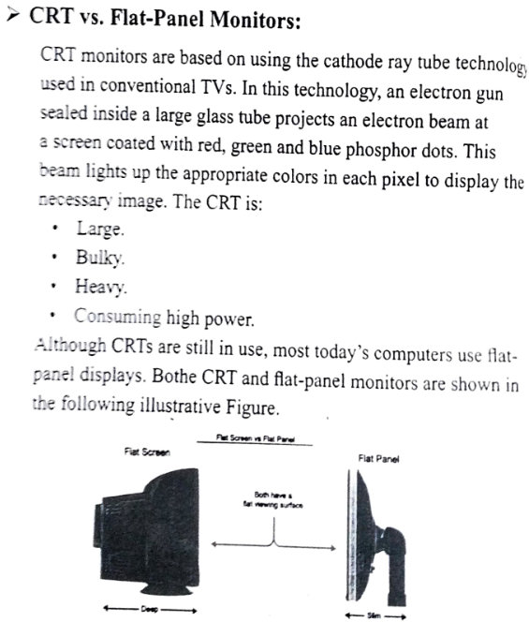

Main Features of a Display Unit
# Source: Academic source: Provided by: [Data Path: Persons Table -> ID Column: 1, Name_En Column: Motasem Essam] -> From: [Data Path: Sources Table -> ID Column: 161, Content Title Column: Academic Source - Modern academy - 2017-2018 - Intro to Computer Science - Input and output devices] -> at: [Document, page: 20, all, “Image - Tool: [Lightshot Program]”] on [4/22/2026]
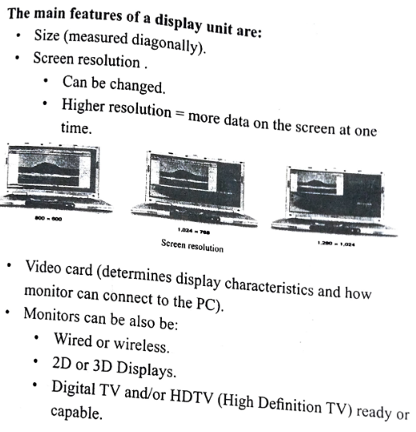
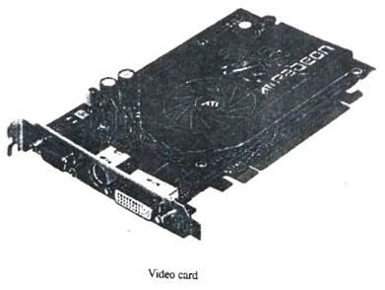

Flat-panel Display Technologies
# Source: Academic source: Provided by: [Data Path: Persons Table -> ID Column: 1, Name_En Column: Motasem Essam] -> From: [Data Path: Sources Table -> ID Column: 161, Content Title Column: Academic Source - Modern academy - 2017-2018 - Intro to Computer Science - Input and output devices] -> at: [Document, page: 21, all, “Image - Tool: [Lightshot Program]”] on [4/22/2026]
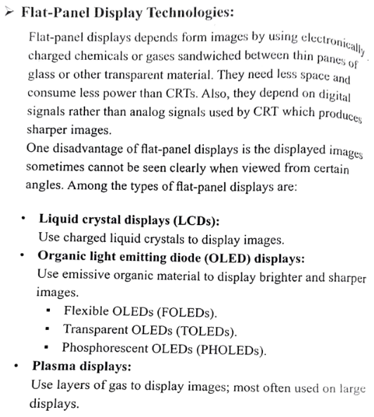
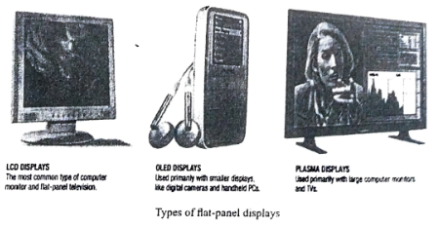

# Source: Academic source: Provided by: [Data Path: Persons Table -> ID Column: 1, Name_En Column: Motasem Essam] -> From: [Data Path: Sources Table -> ID Column: 161, Content Title Column: Academic Source - Modern academy - 2017-2018 - Intro to Computer Science - Input and output devices] -> at: [Document, page: 22, top, “Image - Tool: [Lightshot Program]”] on [4/22/2026]
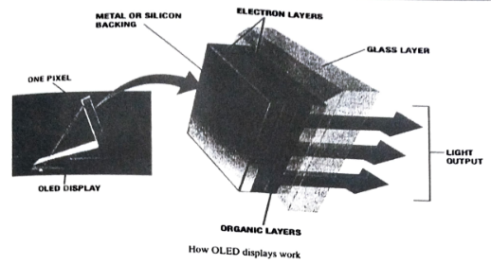

Data and Multimedia Projectors
# Source: Academic source: Provided by: [Data Path: Persons Table -> ID Column: 1, Name_En Column: Motasem Essam] -> From: [Data Path: Sources Table -> ID Column: 161, Content Title Column: Academic Source - Modern academy - 2017-2018 - Intro to Computer Science - Input and output devices] -> at: [Document, page: 22, (middle, bottom), “Image - Tool: [Lightshot Program]”] on [4/22/2026]
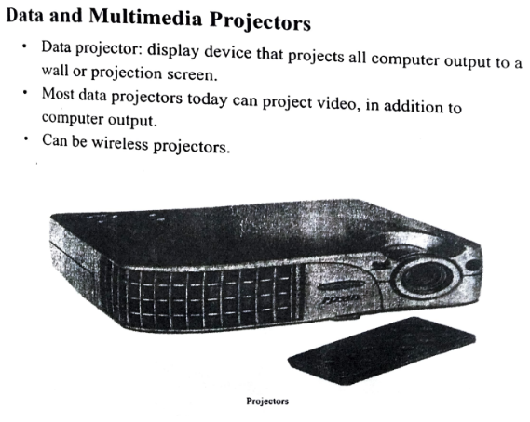

Printers
# Source: Academic source: Provided by: [Data Path: Persons Table -> ID Column: 1, Name_En Column: Motasem Essam] -> From: [Data Path: Sources Table -> ID Column: 161, Content Title Column: Academic Source - Modern academy - 2017-2018 - Intro to Computer Science - Input and output devices] -> at: [Document, page: 23, top, “Image - Tool: [Lightshot Program]”] on [4/22/2026]
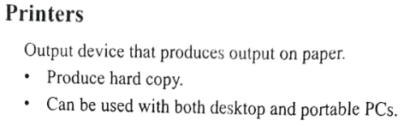

Printer characteristics
# Source: Academic source: Provided by: [Data Path: Persons Table -> ID Column: 1, Name_En Column: Motasem Essam] -> From: [Data Path: Sources Table -> ID Column: 161, Content Title Column: Academic Source - Modern academy - 2017-2018 - Intro to Computer Science - Input and output devices] -> at: [Document, page: 23, (middle, bottom), “Image - Tool: [Lightshot Program]”] on [4/22/2026]
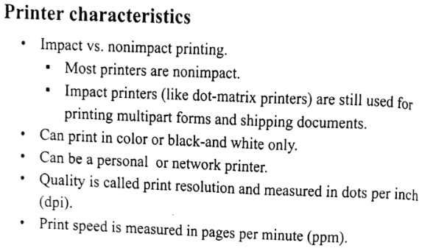

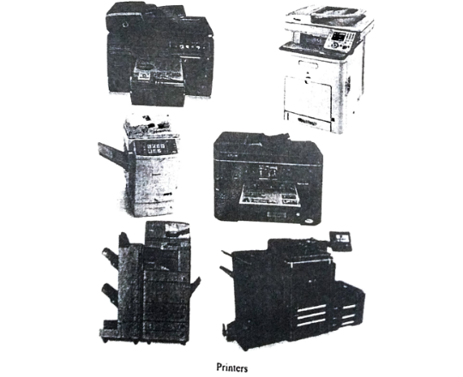

Laser Printers
# Source: Academic source: Provided by: [Data Path: Persons Table -> ID Column: 1, Name_En Column: Motasem Essam] -> From: [Data Path: Sources Table -> ID Column: 161, Content Title Column: Academic Source - Modern academy - 2017-2018 - Intro to Computer Science - Input and output devices] -> at: [Document, page: 24, all, “Image - Tool: [Lightshot Program]”] on [4/22/2026]
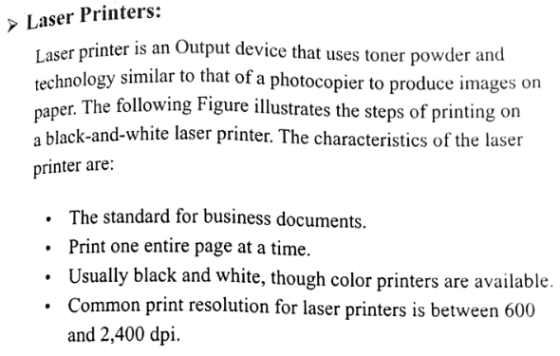
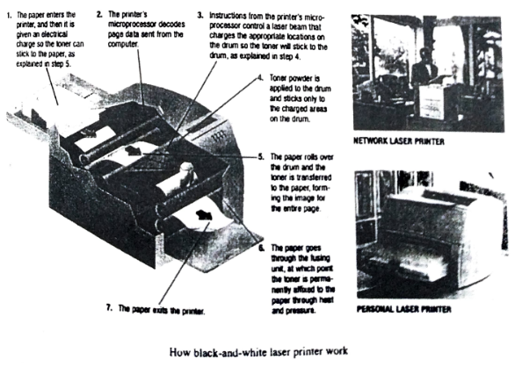

Int-Jet Printers
# Source: Academic source: Provided by: [Data Path: Persons Table -> ID Column: 1, Name_En Column: Motasem Essam] -> From: [Data Path: Sources Table -> ID Column: 161, Content Title Column: Academic Source - Modern academy - 2017-2018 - Intro to Computer Science - Input and output devices] -> at: [Document, page: 25, all, “Image - Tool: [Lightshot Program]”] on [4/22/2026]
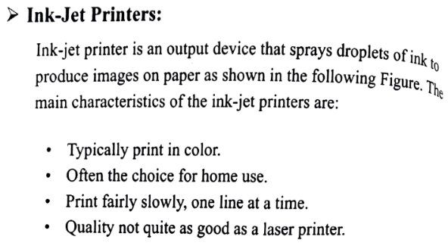
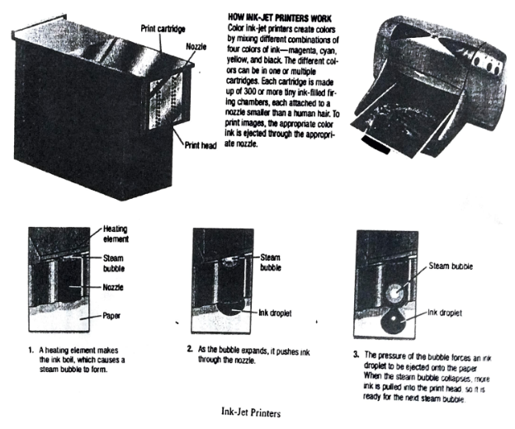

Special Purpose Printers
# Source: Academic source: Provided by: [Data Path: Persons Table -> ID Column: 1, Name_En Column: Motasem Essam] -> From: [Data Path: Sources Table -> ID Column: 161, Content Title Column: Academic Source - Modern academy - 2017-2018 - Intro to Computer Science - Input and output devices] -> at: [Document, page: 26, all, “Image - Tool: [Lightshot Program]”] on [4/22/2026]
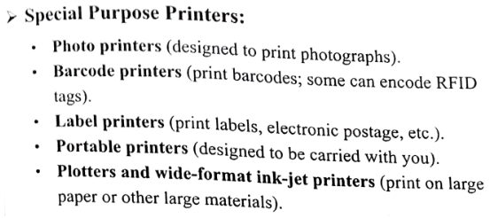
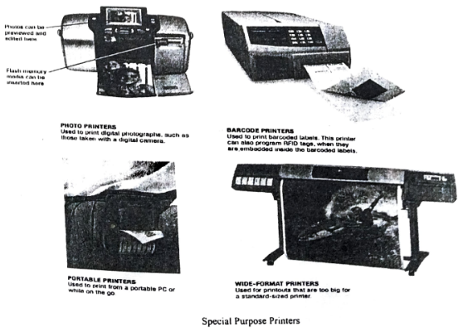

Multifunction Device
# Source: Academic source: Provided by: [Data Path: Persons Table -> ID Column: 1, Name_En Column: Motasem Essam] -> From: [Data Path: Sources Table -> ID Column: 161, Content Title Column: Academic Source - Modern academy - 2017-2018 - Intro to Computer Science - Input and output devices] -> at: [Document, page: 27, all, “Image - Tool: [Lightshot Program]”] on [4/22/2026]
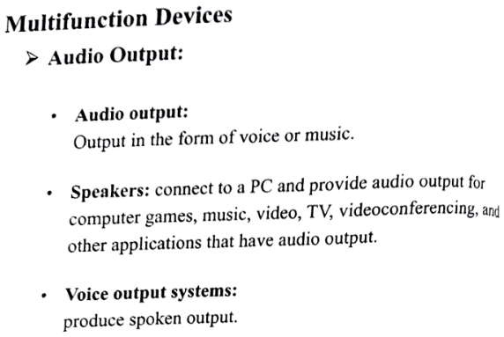
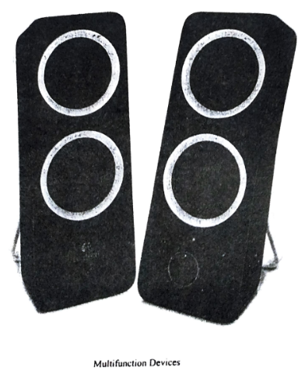

Memory or RAM
# Source: Academic source: Provided by: [Data Path: Persons Table -> ID Column: 1, Name_En Column: Motasem Essam] -> From: [Data Path: Sources Table -> ID Column: 158, Content Title Column: Academic Source - Modern academy - 2017-2018 - Intro to Computer Science - Computer systems] -> at: [Document, page: 7, top, “Image - Tool: [Lightshot Program]”] on [4/22/2026]
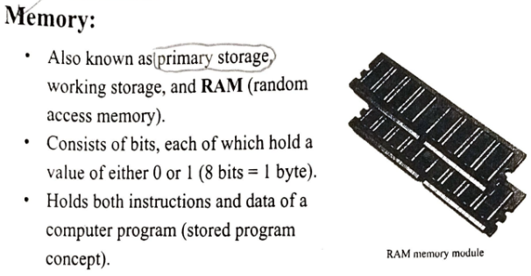
# Source: Academic source: Provided by: [Data Path: Persons Table -> ID Column: 1, Name_En Column: Motasem Essam] -> From: [Data Path: Sources Table -> ID Column: 159, Content Title Column: Academic Source - Modern academy - 2017-2018 - Intro to Computer Science - The System Unit processing and memory] -> at: [Document, page: 20, all , “Image - Tool: [Lightshot Program]”] on [4/22/2026]
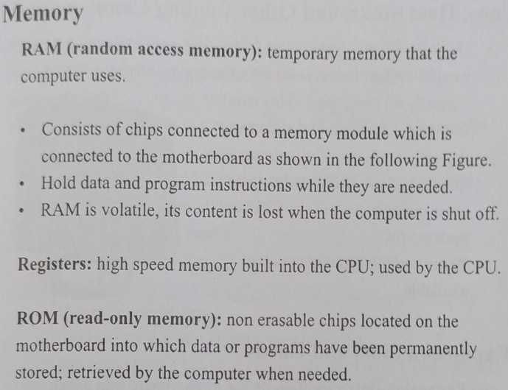
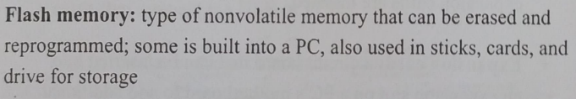
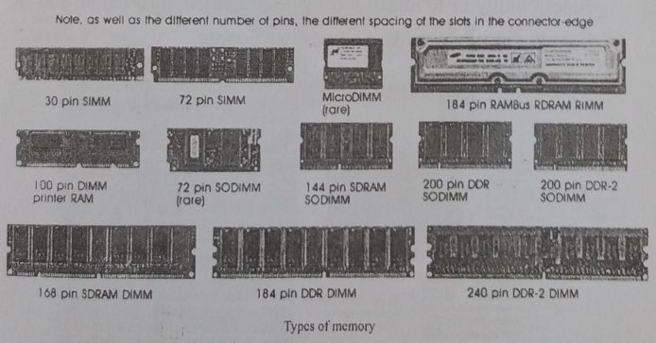

Definition
# Source: AI Source: Provided by: [Data Path: Persons Table -> ID Column: 1, Name_En Column: Motasem Essam] -> From: [ChatGPT] on [4/22/2026]
RAM is a type of computer memory that temporarily stores data and instructions that the CPU is currently using.

🧠 Simple idea
# Source: AI Source: Provided by: [Data Path: Persons Table -> ID Column: 1, Name_En Column: Motasem Essam] -> From: [ChatGPT] on [4/22/2026]
RAM is like the computer’s short-term memory:
- It holds data while the computer is running
- When the computer is turned off, the data is lost

⚙️ What it looks like
# Source: AI Source: Provided by: [Data Path: Persons Table -> ID Column: 1, Name_En Column: Motasem Essam] -> From: [ChatGPT] on [4/22/2026]
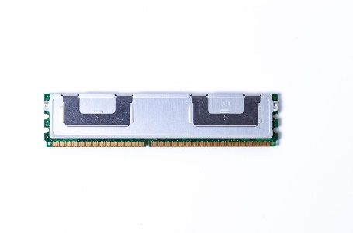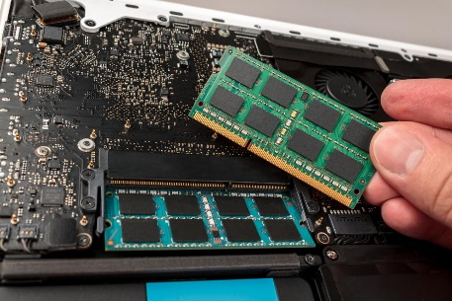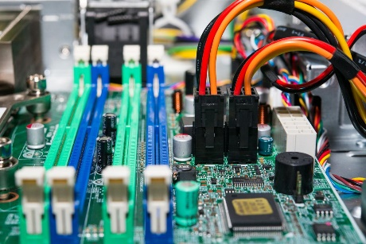

🔧 What RAM does
# Source: AI Source: Provided by: [Data Path: Persons Table -> ID Column: 1, Name_En Column: Motasem Essam] -> From: [ChatGPT] on [4/22/2026]
- Stores programs currently in use
- Holds data the CPU needs quickly
- Helps the computer run fast and smoothly

⚡ Key features
# Source: AI Source: Provided by: [Data Path: Persons Table -> ID Column: 1, Name_En Column: Motasem Essam] -> From: [ChatGPT] on [4/22/2026]
- Volatile memory → loses data when power is off
- Fast access speed
- Directly used by the CPU

🌍 Example
# Source: AI Source: Provided by: [Data Path: Persons Table -> ID Column: 1, Name_En Column: Motasem Essam] -> From: [ChatGPT] on [4/22/2026]
When you:
- Open a browser
- Play a game
- Use an app
👉 The data is loaded into RAM so it can run quickly.

💾 History of RAM (Random Access Memory)
# Source: AI Source: Provided by: [Data Path: Persons Table -> ID Column: 1, Name_En Column: Motasem Essam] -> From: [ChatGPT] on [4/22/2026]
The history of RAM shows how computer memory evolved from large, slow, and physical systems to today’s fast, tiny, and powerful chips.

⚙️ 1. Early Memory (1940s–1950s)
# Source: AI Source: Provided by: [Data Path: Persons Table -> ID Column: 1, Name_En Column: Motasem Essam] -> From: [ChatGPT] on [4/22/2026]
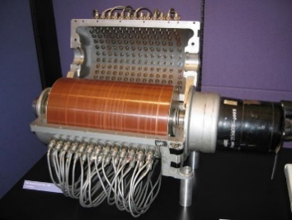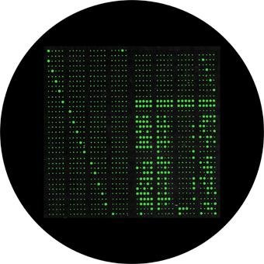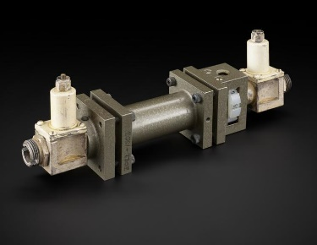
🔹 Technologies:
- Magnetic drum memory
- Williams tube (CRT-based memory)
- Delay line memory
🔹 Features:
- Very large and slow
- Limited storage capacity
- Used in first-generation computers

🧲 2. Magnetic Core Memory (1950s–1970s)
# Source: AI Source: Provided by: [Data Path: Persons Table -> ID Column: 1, Name_En Column: Motasem Essam] -> From: [ChatGPT] on [4/22/2026]
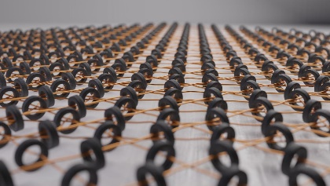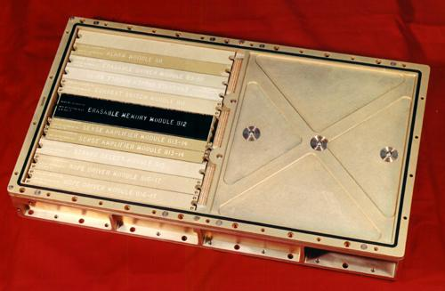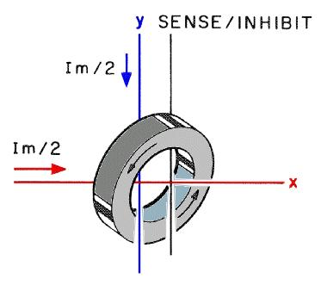
🔹 Technology:
- Tiny magnetic rings (cores)
🔹 Features:
- Faster and more reliable
- Data stored using magnetic polarity
- Non-volatile (data not lost immediately)
👉 Used in early mainframe computers and space missions

💡 3. Semiconductor Memory (1970s)
# Source: AI Source: Provided by: [Data Path: Persons Table -> ID Column: 1, Name_En Column: Motasem Essam] -> From: [ChatGPT] on [4/22/2026]
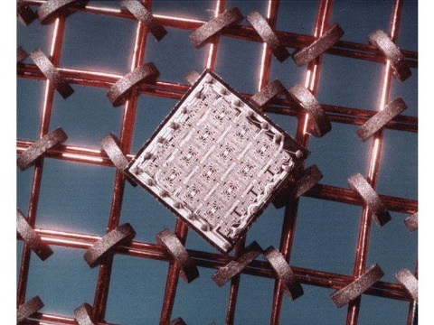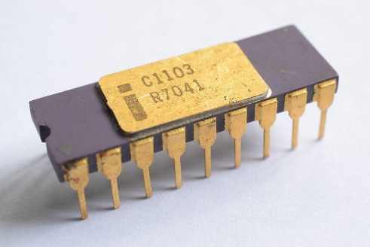
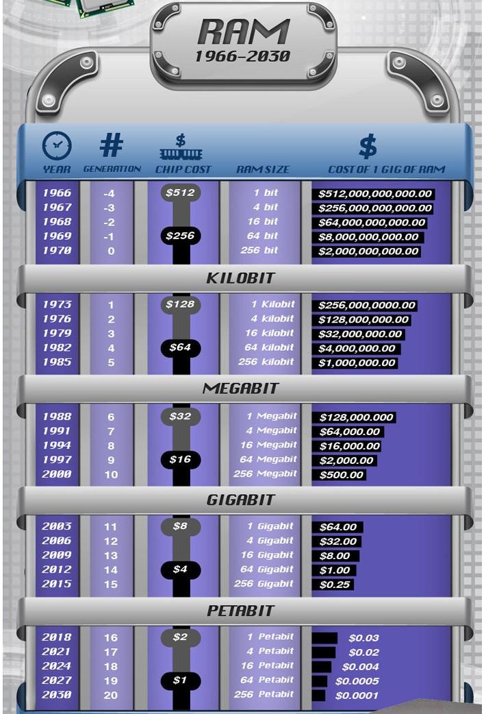
🔹 Technology:
- IC-based memory (silicon chips)
🔹 Features:
- Smaller and faster
- Replaced magnetic core memory
- Beginning of modern RAM

⚡ 4. DRAM & SRAM Era (1980s–Present)
# Source: AI Source: Provided by: [Data Path: Persons Table -> ID Column: 1, Name_En Column: Motasem Essam] -> From: [ChatGPT] on [4/22/2026]
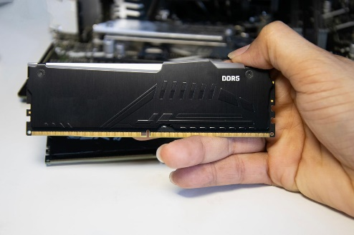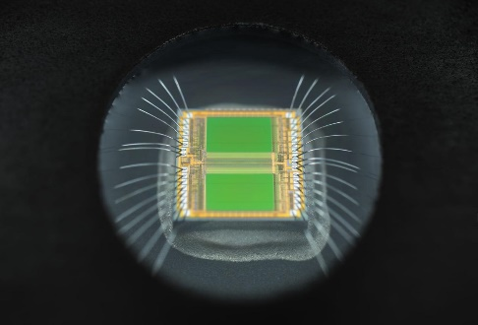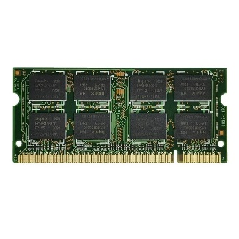
🔹 Types:
- DRAM (Dynamic RAM) → used as main memory
- SRAM (Static RAM) → used in cache
🔹 Features:
- Very fast and efficient
- High storage capacity
- Used in all modern computers

🚀 5. Modern & Future RAM
# Source: AI Source: Provided by: [Data Path: Persons Table -> ID Column: 1, Name_En Column: Motasem Essam] -> From: [ChatGPT] on [4/22/2026]
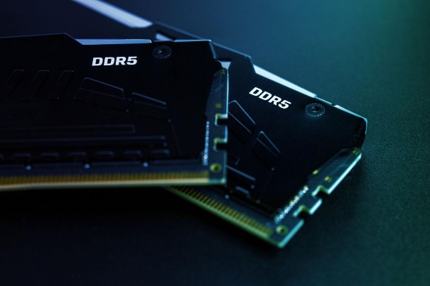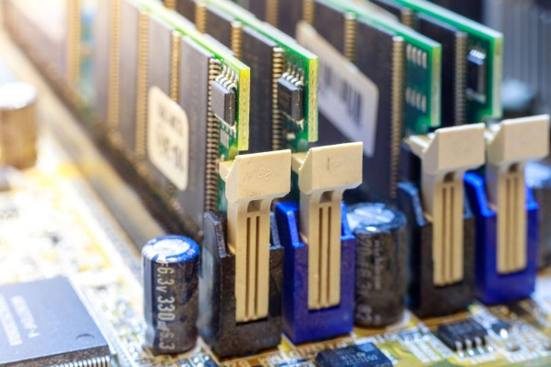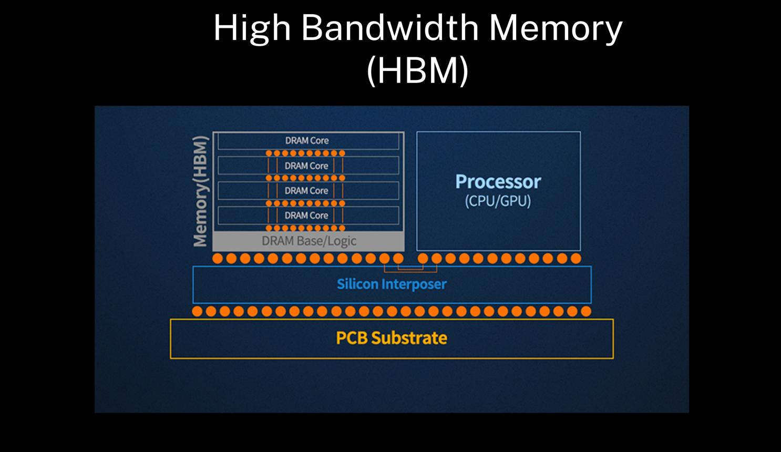
🔹 Developments:
- DDR4, DDR5 RAM
- High Bandwidth Memory (HBM)
- Low-power mobile RAM
🔹 Focus:
- Faster speed
- Lower energy consumption
- Higher capacity

🧠 Timeline Summary
# Source: AI Source: Provided by: [Data Path: Persons Table -> ID Column: 1, Name_En Column: Motasem Essam] -> From: [ChatGPT] on [4/22/2026]
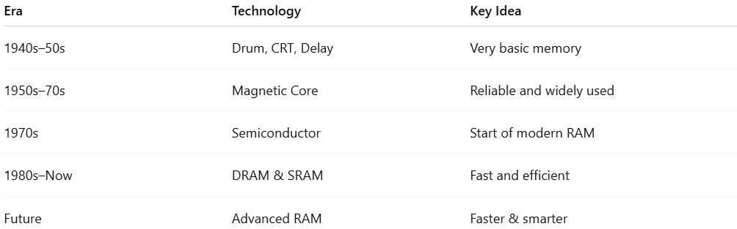
Era | Technology | Key Idea
1940s–50s | Drum, CRT, Delay | Very basic memory
1950s–70s | Magnetic Core | Reliable and widely used
1970s | Semiconductor | Start of modern RAM
1980s–Now | DRAM & SRAM | Fast and efficient
Future | Advanced RAM | Faster & smarter

🧾 One-line summary
# Source: AI Source: Provided by: [Data Path: Persons Table -> ID Column: 1, Name_En Column: Motasem Essam] -> From: [ChatGPT] on [4/22/2026]
The history of RAM shows the evolution from large mechanical and magnetic systems to fast semiconductor memory used in modern computers.

⚙️ Types of RAM
# Source: AI Source: Provided by: [Data Path: Persons Table -> ID Column: 1, Name_En Column: Motasem Essam] -> From: [ChatGPT] on [4/22/2026]
RAM (Random Access Memory) is mainly divided into two primary types, with several subtypes used in modern computers.

🔹 1. DRAM (Dynamic RAM)
# Source: AI Source: Provided by: [Data Path: Persons Table -> ID Column: 1, Name_En Column: Motasem Essam] -> From: [ChatGPT] on [4/22/2026]
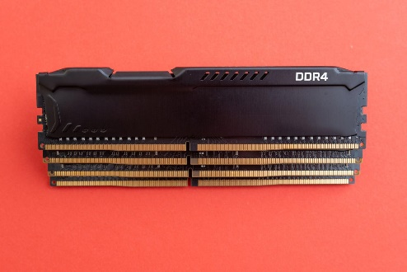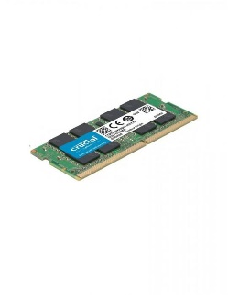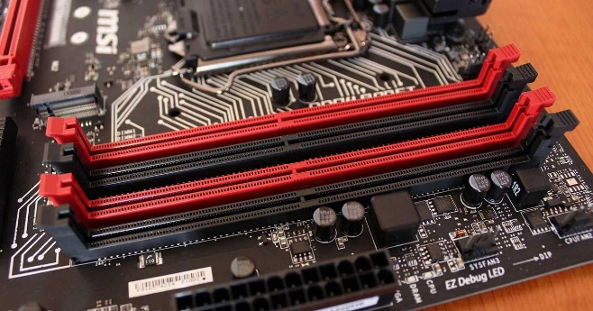
🧠 What it is
DRAM stores data using tiny capacitors that need to be refreshed continuously.
⚙️ Features
- Slower than SRAM
- Cheaper and higher capacity
- Needs constant refreshing
- Used as main memory in computers
🔹 Common types of DRAM
- SDRAM (Synchronous DRAM)
- DDR RAM (DDR2, DDR3, DDR4, DDR5)

Types of DRAM

🔹 SDRAM (Synchronous DRAM)
# Source: AI Source: Provided by: [Data Path: Persons Table -> ID Column: 1, Name_En Column: Motasem Essam] -> From: [ChatGPT] on [4/22/2026]
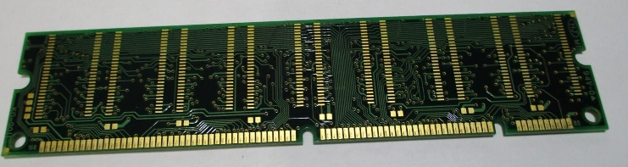
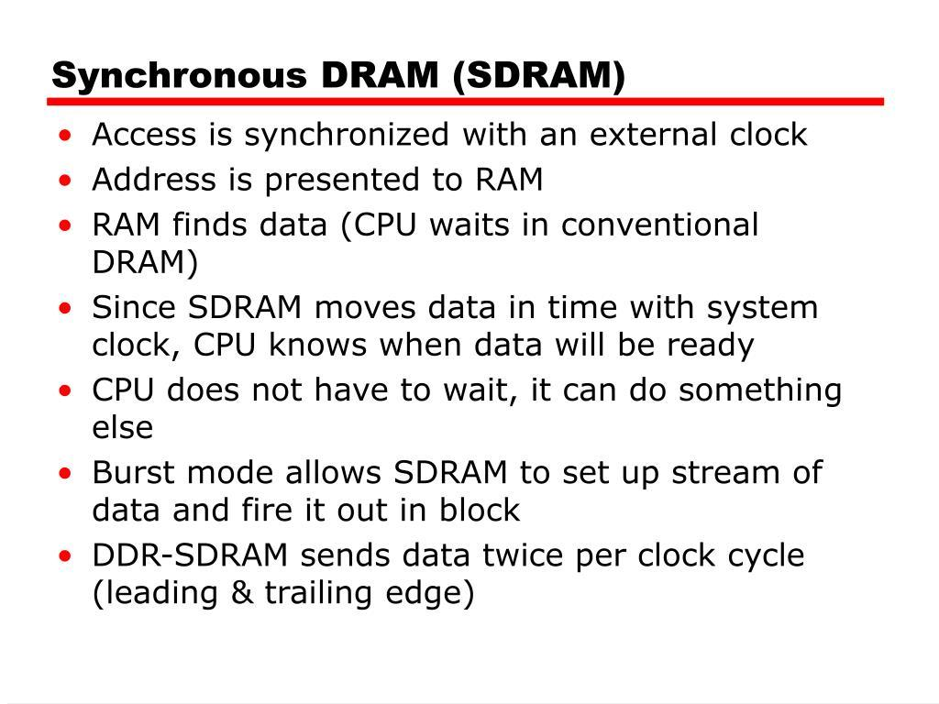
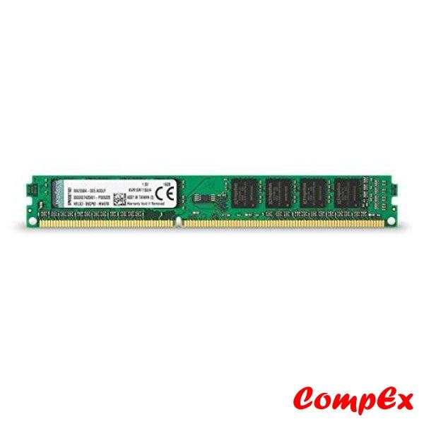
🧠 What it is
SDRAM is a type of DRAM that works in sync with the computer’s clock speed.
⚙️ Key features
- Operates synchronously with the CPU clock
- Faster than older DRAM (asynchronous DRAM)
- Transfers data at one operation per clock cycle
- Used in older computers
📌 Key idea
👉 “Synchronous” = works in step with the system clock

🔹 DDR RAM (Double Data Rate RAM)
🧠 What it is
DDR RAM is an improved version of SDRAM that can transfer data twice per clock cycle, making it much faster.
👉 “Double Data Rate” = data is transferred on both the rising and falling edges of the clock signal

🔸 DDR2
# Source: AI Source: Provided by: [Data Path: Persons Table -> ID Column: 1, Name_En Column: Motasem Essam] -> From: [ChatGPT] on [4/22/2026]
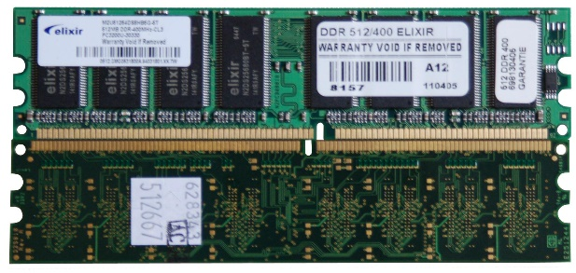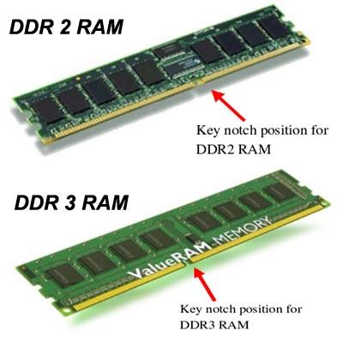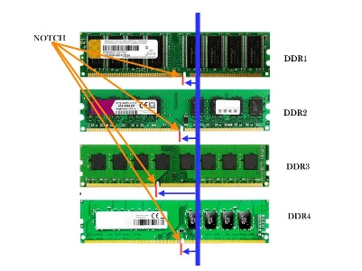
Features:
- Faster than DDR
- Lower power consumption than DDR
- Now outdated

🔸 DDR3
# Source: AI Source: Provided by: [Data Path: Persons Table -> ID Column: 1, Name_En Column: Motasem Essam] -> From: [ChatGPT] on [4/22/2026]
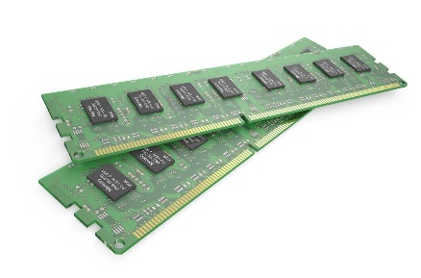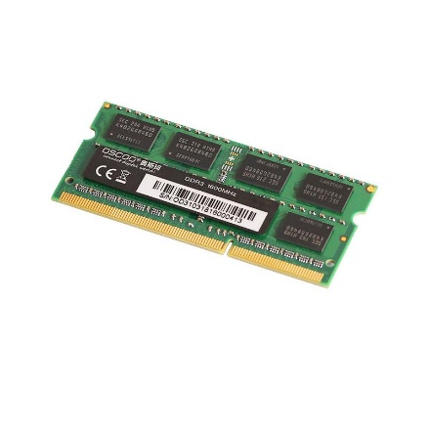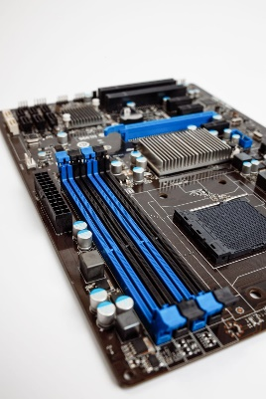
Features:
- Higher speed than DDR2
- Lower voltage → more energy efficient
- Widely used in older modern PCs

🔸 DDR4
# Source: AI Source: Provided by: [Data Path: Persons Table -> ID Column: 1, Name_En Column: Motasem Essam] -> From: [ChatGPT] on [4/22/2026]
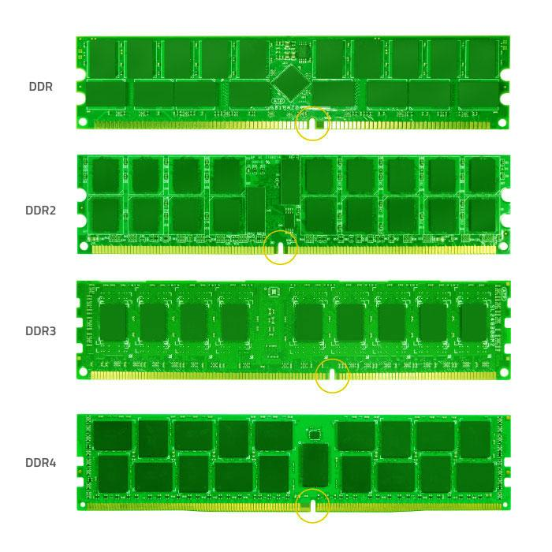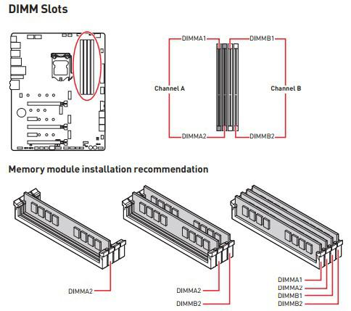
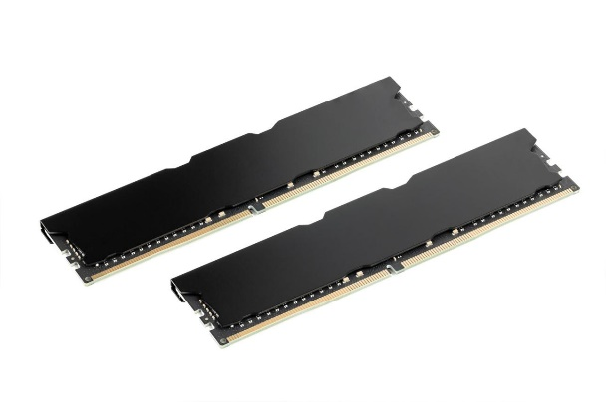
Features:
- Faster and more efficient than DDR3
- Higher capacity (more GB supported)
- Common in many current computers

🔸 DDR5
# Source: AI Source: Provided by: [Data Path: Persons Table -> ID Column: 1, Name_En Column: Motasem Essam] -> From: [ChatGPT] on [4/22/2026]
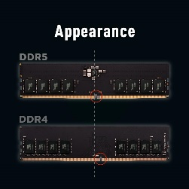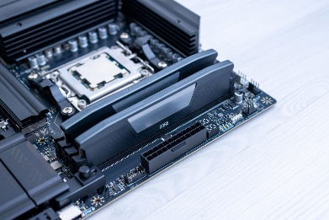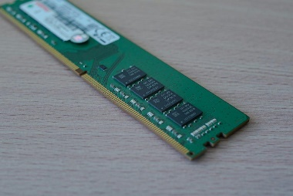
Features:
- Much higher speed
- Better performance and efficiency
- Supports very large memory sizes
- Used in latest modern systems

⚡ Quick Comparison
# Source: AI Source: Provided by: [Data Path: Persons Table -> ID Column: 1, Name_En Column: Motasem Essam] -> From: [ChatGPT] on [4/22/2026]
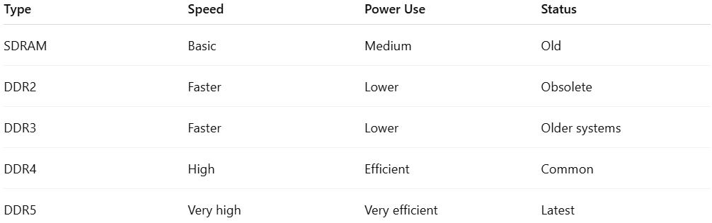
Type | Speed | Power Use | Status
SDRAM | Basic | Medium | Old
DDR2 | Faster | Lower | Obsolete
DDR3 | Faster | Lower | Older systems
DDR4 | High | Efficient | Common
DDR5 | Very high | Very efficient | Latest

🧾 One-line summary
# Source: AI Source: Provided by: [Data Path: Persons Table -> ID Column: 1, Name_En Column: Motasem Essam] -> From: [ChatGPT] on [4/22/2026]
- SDRAM = synchronized with clock, single data transfer
- DDR RAM = improved SDRAM with double data transfer, evolving from DDR2 → DDR5 with increasing speed and efficiency

🔑 Easy memory tip
# Source: AI Source: Provided by: [Data Path: Persons Table -> ID Column: 1, Name_En Column: Motasem Essam] -> From: [ChatGPT] on [4/22/2026]
👉 “DDR = Double speed improvement over SDRAM, and each new version is faster than the previous one.”

🔹 2. SRAM (Static RAM)
# Source: AI Source: Provided by: [Data Path: Persons Table -> ID Column: 1, Name_En Column: Motasem Essam] -> From: [ChatGPT] on [4/22/2026]
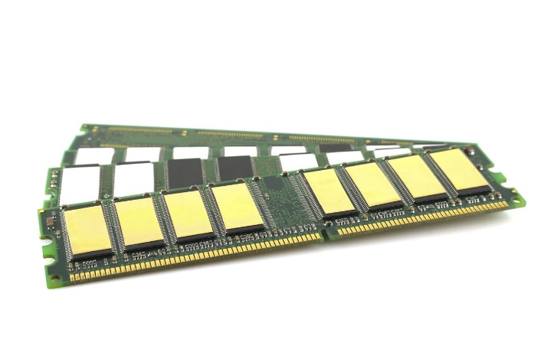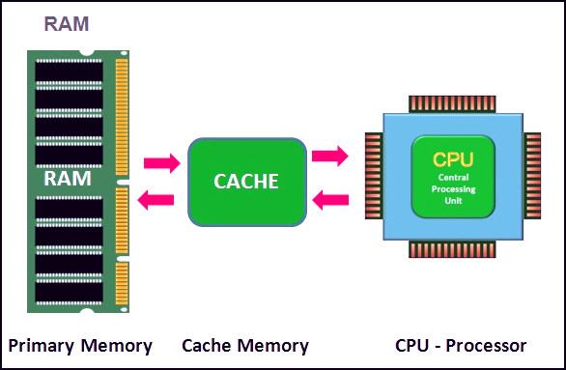
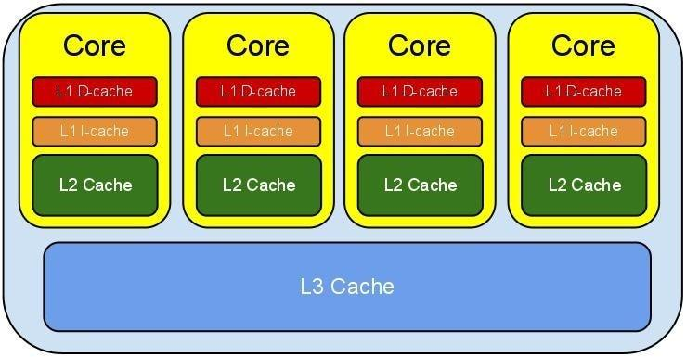
🧠 What it is
SRAM stores data using flip-flop circuits and does not need refreshing.

⚙️ Features
# Source: AI Source: Provided by: [Data Path: Persons Table -> ID Column: 1, Name_En Column: Motasem Essam] -> From: [ChatGPT] on [4/22/2026]
- Very fast
- More expensive
- Lower capacity
- Used in cache memory (CPU cache)

⚡ Key Differences
# Source: AI Source: Provided by: [Data Path: Persons Table -> ID Column: 1, Name_En Column: Motasem Essam] -> From: [ChatGPT] on [4/22/2026]

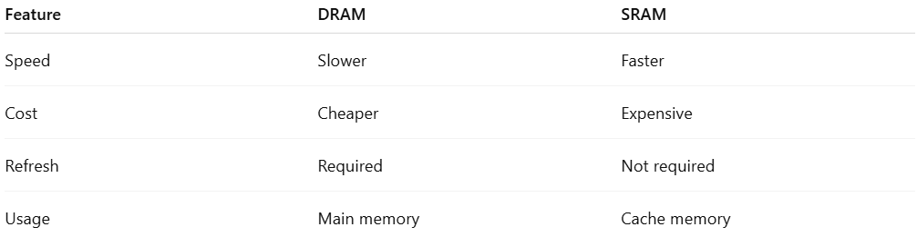
Feature | DRAM | SRAM
Speed | Slower | Faster
Cost | Cheaper | Expensive
Refresh | Required | Not required
Usage | Main memory | Cache memory

🧠 Performance Comparison of RAM Types
# Source: AI Source: Provided by: [Data Path: Persons Table -> ID Column: 1, Name_En Column: Motasem Essam] -> From: [ChatGPT] on [4/22/2026]
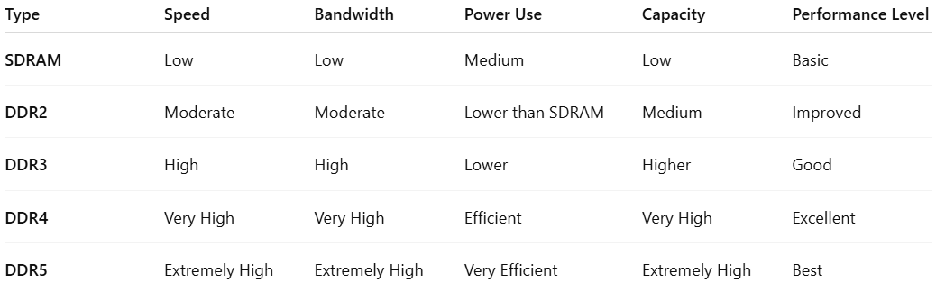
Type | Speed | Bandwidth | Power Use | Capacity | Performance Level
SDRAM | Low | Low | Medium | Low | Basic
DDR2 | Moderate | Moderate | Lower than SDRAM | Medium | Improved
DDR3 | High | High | Lower | Higher | Good
DDR4 | Very High | Very High | Efficient | Very High | Excellent
DDR5 | Extremely High | Extremely High | Very Efficient | Extremely High | Best

🔄 Real-world impact
# Source: AI Source: Provided by: [Data Path: Persons Table -> ID Column: 1, Name_En Column: Motasem Essam] -> From: [ChatGPT] on [4/22/2026]
- More RAM speed → faster apps and gaming
- Higher capacity → better multitasking
- Lower power → longer battery life (laptops)

🧾 One-line summary
# Source: AI Source: Provided by: [Data Path: Persons Table -> ID Column: 1, Name_En Column: Motasem Essam] -> From: [ChatGPT] on [4/22/2026]
RAM has two main types: DRAM (main memory, slower, cheaper) and SRAM (cache memory, faster, more expensive).

🔑 Easy way to remember
# Source: AI Source: Provided by: [Data Path: Persons Table -> ID Column: 1, Name_En Column: Motasem Essam] -> From: [ChatGPT] on [4/22/2026]
- D in DRAM = “Dynamic” (keeps refreshing)
- S in SRAM = “Static” (stable, no refresh)

🔄 RAM vs Storage
# Source: AI Source: Provided by: [Data Path: Persons Table -> ID Column: 1, Name_En Column: Motasem Essam] -> From: [ChatGPT] on [4/22/2026]
- RAM = temporary, fast
- Hard disk/SSD = permanent, slower

🧾 One-line definition
# Source: AI Source: Provided by: [Data Path: Persons Table -> ID Column: 1, Name_En Column: Motasem Essam] -> From: [ChatGPT] on [4/22/2026]
RAM is temporary memory that stores data and programs currently being used by the computer.

🔑 Key idea
# Source: AI Source: Provided by: [Data Path: Persons Table -> ID Column: 1, Name_En Column: Motasem Essam] -> From: [ChatGPT] on [4/22/2026]
More RAM = better multitasking and performance.

The Motherboard
# Source: Academic source: Provided by: [Data Path: Persons Table -> ID Column: 1, Name_En Column: Motasem Essam] -> From: [Data Path: Sources Table -> ID Column: 159, Content Title Column: Academic Source - Modern academy - 2017-2018 - Intro to Computer Science - The System Unit processing and memory] -> at: [Document, page: 18, top, “Image - Tool: [Lightshot Program]”] on [4/22/2026]
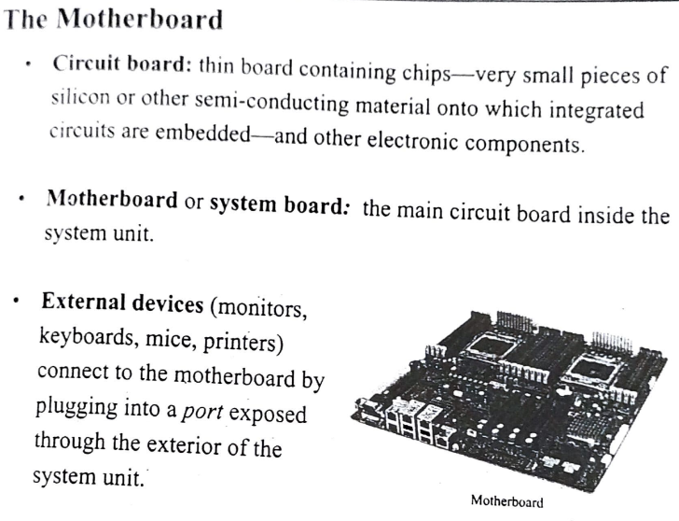

Buses
# Source: Academic source: Provided by: [Data Path: Persons Table -> ID Column: 1, Name_En Column: Motasem Essam] -> From: [Data Path: Sources Table -> ID Column: 159, Content Title Column: Academic Source - Modern academy - 2017-2018 - Intro to Computer Science - The System Unit processing and memory] -> at: [Document, page: 22, all, “Image - Tool: [Lightshot Program]”] on [4/22/2026]
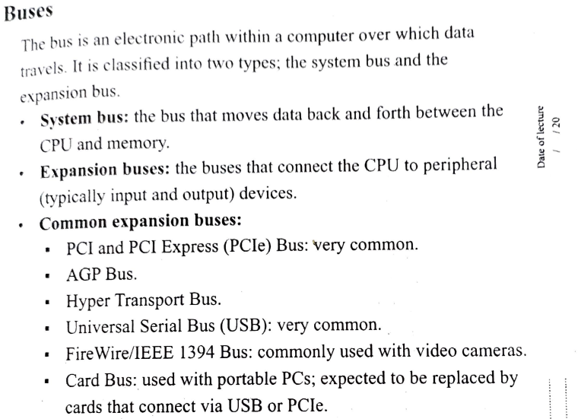
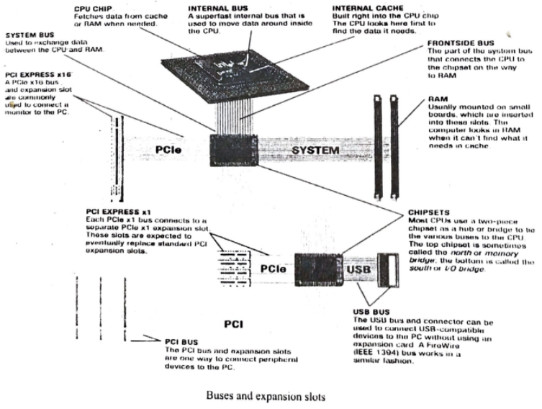

Ports
# Source: Academic source: Provided by: [Data Path: Persons Table -> ID Column: 1, Name_En Column: Motasem Essam] -> From: [Data Path: Sources Table -> ID Column: 159, Content Title Column: Academic Source - Modern academy - 2017-2018 - Intro to Computer Science - The System Unit processing and memory] -> at: [Document, page: 22, all, “Image - Tool: [Lightshot Program]”] on [4/22/2026]
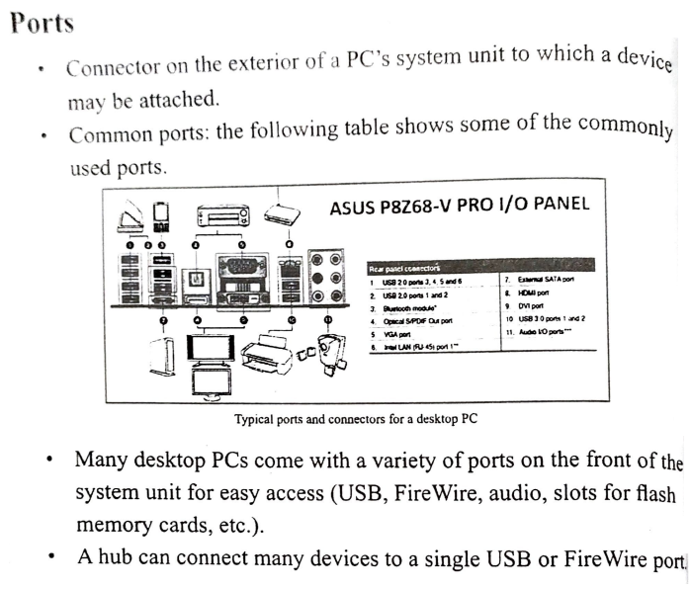
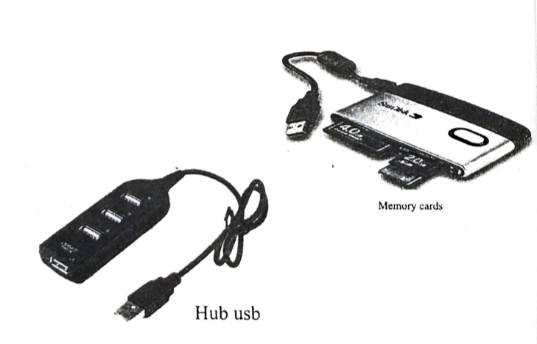

Cooling Components
# Source: Academic source: Provided by: [Data Path: Persons Table -> ID Column: 1, Name_En Column: Motasem Essam] -> From: [Data Path: Sources Table -> ID Column: 159, Content Title Column: Academic Source - Modern academy - 2017-2018 - Intro to Computer Science - The System Unit processing and memory] -> at: [Document, page: 21, top, “Image - Tool: [Lightshot Program]”] on [4/22/2026]
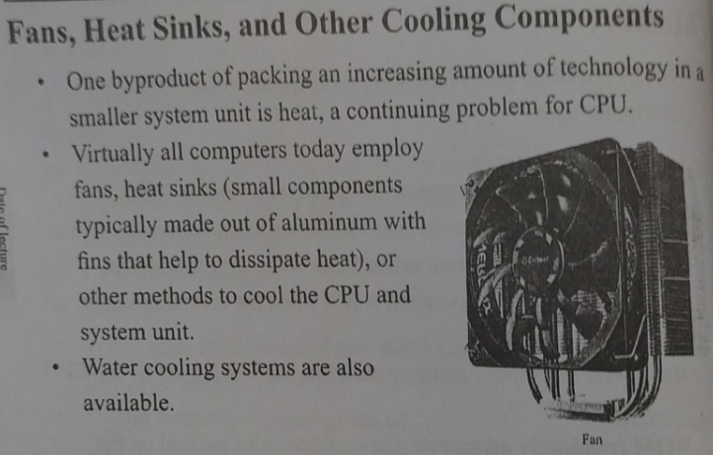

Expansion Slots and Cards
# Source: Academic source: Provided by: [Data Path: Persons Table -> ID Column: 1, Name_En Column: Motasem Essam] -> From: [Data Path: Sources Table -> ID Column: 159, Content Title Column: Academic Source - Modern academy - 2017-2018 - Intro to Computer Science - The System Unit processing and memory] -> at: [Document, page: 21, (middle, ,bottom), “Image - Tool: [Lightshot Program]”] on [4/22/2026]
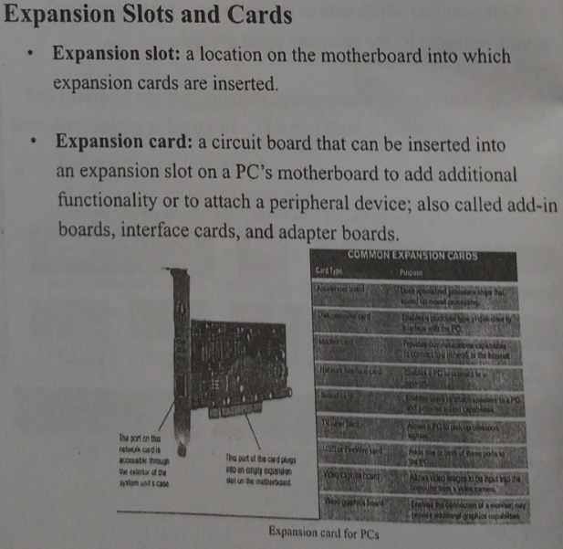

⚙️ What hardware does
# Source: AI Source: Provided by: [Data Path: Persons Table -> ID Column: 1, Name_En Column: Motasem Essam] -> From: [ChatGPT] on [4/22/2026]
- Receives input (data)
- Processes it (with CPU)
- Produces output (information)
- Stores data for future use

🔄 Hardware vs Software
# Source: AI Source: Provided by: [Data Path: Persons Table -> ID Column: 1, Name_En Column: Motasem Essam] -> From: [ChatGPT] on [4/22/2026]
- Hardware = physical parts
- Software = programs/instructions that control hardware
👉 They must work together for a computer to function.

🧾 One-line definition
# Source: AI Source: Provided by: [Data Path: Persons Table -> ID Column: 1, Name_En Column: Motasem Essam] -> From: [ChatGPT] on [4/22/2026]
Hardware is the physical components of a computer that you can touch and that perform computing tasks.

